Pontardawe Town Council
Annual Report 2024-25

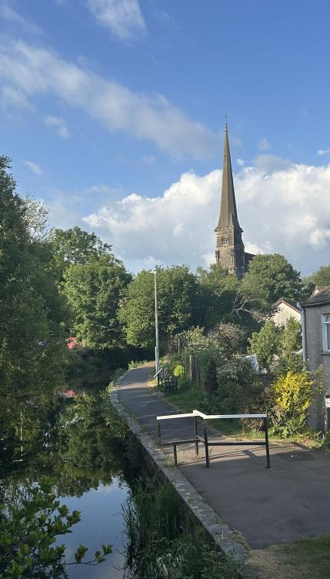

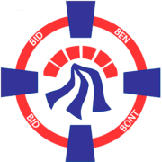

CONTENTS
Page

Mayor’s Foreword 3
Pontardawe 6
Pontardawe Town Council 7
Pontardawe Town Council Meetings, Decisions and Responsibilities
Pontardawe Town Councillors
Finance
Supporting Well-being in Pontardawe
Grants Awarded by Pontardawe Town Council
Achievements at a glance
A Year in Pictures

Mayor’s Foreword

It is a pleasure to present Pontardawe Town Council's Annual Report for 2024-2025. It has been a privilege to fill the role of Mayor of the Town for the past year and I am grateful to those who elected me to the position.

It has been a year of change and further development in the work of the Town Council, and indeed in the history of Pontardawe itself. Whilst we face challenging times in the area and across Wales more widely, it has been wonderful to see members of the community pull together with the Town Council and our County Councillors to work together on various projects. One of those projects is the CCTV system that has been installed in the town thanks to collaboration between the Town and County Council that will contribute further to keeping Pontardawe a safe place for us all. While it is the end of an era with the closure of the town's swimming pool, the Town Council has pressed the County Council constantly to secure new facilities to take its place, knowing how well-used the pool has been by the community. The County Council’s Cabinet Member for Nature, Tourism and Well-being has kept in regular contact with the Town Council about the developments and a report is about to be published by the County Council outlining potential next steps.

The Town Council also completed a project funded by the Heritage Lottery Fund to enhance the town with images of the area’s ancient landmarks and important buildings painted on Openreach cabinets on the streets of Pontardawe, Rhyd-y-fro, Trebanos and Ynysmeudwy. Members of the community, including children from our primary schools, shared their ideas for the project. I am extremely proud of the red dragon that appears on the box on Herbert Street which extends a warm welcome to the town’s visitors! However, this was just one project among several others implemented by the Town Council to improve the area. Other projects included a biodiversity project on Gellionnen Common and Cwm Du Glen funded by the NPT Council Local Nature Partnership and delivered in collaboration with the Pontardawe Conservation Volunteers, the monthly Pontardawe Repair Café at Tŷ’r Gwrhyd Welsh Centre and Family Fun Days at King George V Park.

I had the privilege of attending and supporting several wonderful activities in the community over the year, from the Remembrance service at St Peter’s Church to the Winterfest in December. I chaired the Pontardawe Appeal Committee to raise funds in support of the National Urdd Eisteddfod which Neath Port Talbot County Borough hosted at Margam Park at the end of May 2025. Hard-working members of the committee organised a range of fun activities and events to raise money and it was fantastic to see the support shown by Pontardawe residents towards this amazing youth festival – the largest in Europe, incidentally! The Committee managed to reach its target six months in advance of the event and has since surpassed that target and reached a total of £17,000.

I was also extremely proud to be able to host an evening at Pontardawe Golf Club in November to recognise the fantastic work of many voluntary groups and associations who do so much to enrich life here in Pontardawe, and to thank them. The evening was also an opportunity to mark 10 years since the establishment of the PANTRY Food Bank and to recognise the hard work and dedication of the volunteers over the years. Instead of asking for financial contributions to the Mayor's charity this year, we asked for contributions to the PANTRY and it was touching to see everyone’s generosity.

I chose two active local groups to benefit from Pontardawe Mayor's Charity status for 2024-25, namely My Green Valley and The Boot Room. The residents of Pontardawe will be very familiar, and grateful I'm sure, for the tireless work of the members of My Green Valley in keeping the Swansea Valley free of litter and educating the community about looking after our environment. The second charity may not be as familiar, The Boot Room, but this is an initiative that helps provide free football and rugby boots, as well as clothing and sports kit, to children who cannot afford them. The Boot Room works to ensure that young people are not prevented from taking part in sport because of poverty. These two local charities reflect my passion for our environment, for providing opportunities for children and young people, and also my love of football, and I am proud to support their activities. Thanks to the generosity of Pontardawe residents and other supporters, including the Glantawe Lions, both charities will receive £400 each through the Pontardawe Mayor's Charity to further support and promote their work.

In closing, I would like to warmly thank the Clerk of the Council, Deborah Phillips, for her support throughout the year – I have benefited greatly from her guidance and patient advice, and we are extremely fortunate as a Town Council to benefit from her exceptional organisational, administrative and management skills.

I know from experience that my fellow Plaid Cymru, Labour and Independent councillors on Pontardawe Town Council, not to mention our Youth Councillors, are all passionate about ensuring that our town and its neighbouring villages thrive. I thank everyone for their support and work over the past year and I look forward to supporting further exciting developments in 2025-26.

Gwenno Ffrancon
May 2025
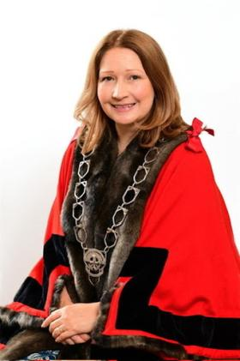
Pontardawe
The town of Pontardawe lies in the Swansea Valley and is named after the bridge crossing the river Tawe name which runs through the town. It appears that some form of a bridge had been in place over the Tawe at this location by 1729, as it features on Emanuel Bowen’s New and Accurate Map of South Wales published in that year. The settlement developed as the crossing point of two drover trails; the one running from Swansea to Brecon, and the other from Neath to Llandeilo. The picturesque canal, now dormant, is evidence of the industrial past of steel, tinplate and coal. Pontardawe is a town with a population of approximately 7,100 according to the 2021 census.

St. Peter’s Church, notable for its French architectural style and affectionately known as “Cadeirlan y Cwm / the Valley’s Cathedral”, was completed in 1862 and its 60m tower and spire continues to stand tall above a town known in the nineteenth-century for its religious Nonconformity and political radicalism.

The Arts Centre at the heart of the town is a blend of contemporary and traditional styles and is steeped in history. Further development of the Arts Centre is set to be completed before the end of 2025 with the creation of a 70-seat cinema in addition to the main theatre and studio rooms. The Town Council office is also situated in this majestic building.

The resilience of the town and its people were celebrated in the Welsh language poems of D. Gwenallt Jones (1899-1968) and Dafydd Rowlands (1931-2001), and it continues to be a thriving centre of Welsh folk culture, as manifest in the success of Mary Hopkin in the 1970s and the continuation of its annual Pontardawe Festival in August. Pontardawe is twinned with Locminé in Brittany.

The town has four primary schools within the Town Council’s ward namely, Ysgol Gynradd Gymraeg Pontardawe, Ysgol Gynradd Gymraeg Trebannws, Llangiwg Primary School, and Rhyd-y-fro Primary School. At present, Godre’r Graig Primary School is also located in Pontardawe in temporary buildings on a site adjacent to the town’s secondary school, Cwm Tawe Community School. Pupils choosing to receive their secondary education in Welsh travel a short distance to Ysgol Gyfun Gymraeg Ystalyfera.

Sports and leisure activities are a large part of life in Pontardawe with clubs ranging from football to bowls, and martial arts to cricket all accessible in the town. Trebanos has an impressive sporting legacy with notable people from the village including rugby union players Bleddyn Bowen, who captained Wales to the 1988 Triple Crown, fly-half Arwel Thomas who was capped 23 times, Robert Jones, who was capped 54 times and helped win the 1988 Triple Crown and openside flanker Justin Tipuric who was capped an amazing 93 times for Wales.

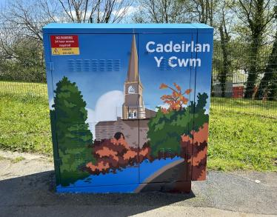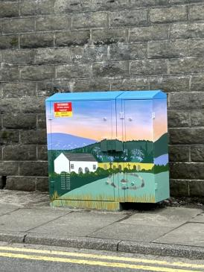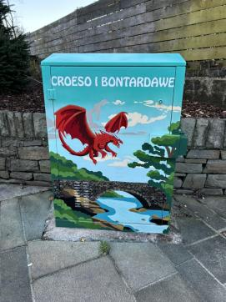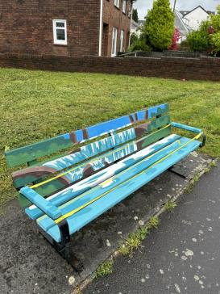
Pontardawe Town Council
Pontardawe Town Council comprises of four separate communities – Pontardawe, Trebanos, Rhyd-y-Fro and Ynysmeudwy, all with their distinct character. The Town Council was originally part of the large Llanguicke Community Council which was separated in 1985/6. The Town Council is comprised of 16 elected members and forms part of the county borough of Neath Port Talbot. Pontardawe Town Council is a separate body to Neath Port Talbot County Borough Council, and therefore, manages different functions and responsibilities.

Pontardawe Town Council’s Annual Report, produced in accordance with requirements of the Local Government and Elections (Wales) Act 2021, aims to inform the community of how the Council delivers against its responsibilities and budgets, who are the elected members of the Council, and provides details of projects that the Council is working to deliver for the town’s benefit.

Pontardawe Town Council Meetings, Decisions and Responsibilities
Pontardawe Town Council, as a body, is responsible for making decisions and managing public money. The Council is open and transparent in decision-making and spending. All decisions are published on the Town Council website within 7 days of a Council meeting being held.

Town Council Ordinary General meetings are held monthly at 6.45pm (usually on the second Monday of each month – except August and Bank Holidays), other committee meetings such as Planning, Policy and Resources, Development, and Eco and Wellbeing are held on the following Monday evenings. Meetings are open to the public, and there is an opportunity for the public to contribute to matters on the agenda, at the beginning of each ordinary meeting.

Details of Committee meetings for the following month are found in each month’s Ordinary General Meeting minutes which can be found on our website http://www.pontardawetowncouncil.gov.wales/

Pontardawe Town Council serve the residents of Pontardawe, Rhyd-y-Fro, Ynysmeudwy and Trebanos and is responsible for a number of assets and facilities. This includes Trebanos, ARCH and Ynysmeudwy Community Halls, Trebanos Park, Ynysmeudwy Park, Parc Chwarae Teg, together with the maintenance of some litter bins, highway seating, bridleways, public footpaths, and part of Cwm Du Glen.

The Town Council also works in partnership with the Unitary Authority, Arts Centre, Chamber of Commerce, local schools, community groups and third sector organisations to obtain grant funding and organise events.

We also provide grants to local groups which can be used for both capital projects and revenue.
Details of finance, policy documents, Council activity and additional information about the Council can be found on our website.

Role within Local Government
Pontardawe Town Council is within one tier of local government, another tier would be Neath Port Talbot County Borough Council as the unitary authority. Both Councils are corporate bodies and therefore decisions are made as a whole. The Town Council has the right to raise money through taxation via a precept and to spend in accordance with the legal powers.

Our current Councillors were elected in 2022, however should an elected Councillor leave within their term, then Councillors can be co-opted by Council if a by-election is not requested by the community.
Council Members come from varied backgrounds and this representation on the Town Council means that they bring a number of skills and areas of expertise to discussion.

The Mayor is the face of the Council, attending events and chairing Town Council meetings. The Town Council also employs staff who are managed by the Clerk, who is the proper officer of the Council, in law. The Clerk provides advice and support and acts to implement Council decisions. The Clerk has a varied role and is answerable only to the Council as a whole.

Neath Port Talbot County Borough Council
Neath Port Talbot County Borough Council is responsible for services including education, health and social services, leisure, refuse and recycling, street cleaning, highways including both roads and pavements – street lighting and libraries, their staff are able to assist with queries relating to these matters and can be contacted by telephone on 01639 686868 or via email, in person or by post. Details of how to contact Neath Port Talbot Council can be found on their web site at https://www.npt.gov.uk/?lang=en-gb

Pontardawe is also represented by elected Members to the Neath Port Talbot Council and who can assist residents with issues relating to Neath Port Talbot Council. The elected Councillors for the Pontardawe ward are Councillor Heath Davies and Councillor Anthony Richards, and for the Trebanos ward it is Councillor Rebeca Phillips. The communities of Ynysmeudwy and Rhyd-y-Fro are covered by the Pontardawe ward Members.

Pontardawe Town Councillors
Representing three wards as follows

Ward | Councillor | Contact Details
Pontardawe | Gary Davies  Labour - Elected | 07580 147304
Pontardawe | Dai Brain  Plaid Cymru - Elected | Cllr.d.brain@gmail.com
Pontardawe | Jill Lord  Labour - Elected | Cllr.J.Lord@gmail.com
Pontardawe | Matt Vincent  Plaid Cymru - Elected | Advertising@southwalesmedia.com
Pontardawe | Meirion Davies  Independent - Elected | info@vesopa.com
Pontardawe | Linet Purcell  Plaid Cymru - Elected | linetpurcell@gmail.com
Pontardawe | Anthony Richards  Plaid Cymru - Elected | cllr.a.j.richards@npt.gov.uk
Pontardawe | Bleddyn Howells  Independent - Elected | Cllr.B.Howells@gmail.com
Pontardawe | Jamie Nemeth  Plaid Cymru - Elected | 07846529813
Pontardawe | Heath Davies  Plaid Cymru - Elected | Cllr.h.davies1@npt.gov.uk
Rhyd-y-Fro | Steve Todd  Labour - Elected | Cllr.s.todd@gmail.com
Rhyd-y-Fro | Paul Temblett  Independent - Elected | P.temblett@talk21.com

Trebanos | Gwenno Ffrancon  Plaid Cymru - Elected | Cllr.g.ffrancon@gmail.com
Trebanos | Rebeca Phillips  Plaid Cymru - Elected | Cllr.r.phillips@npt.gov.uk
Trebanos | Jamie Watkins  Plaid-Cymru - Elected | jamiehwat@gmail.com
Trebanos | Eira Thomas | Stepped down as Councillor in early 2025.  The vacant seat in Trebanos will be filled via a co-option as no by-election has been requested
Youth Councillor | Noel Davies | town.clerk@pontardawetowncouncil.gov.wales
Youth Councillor | Esther Harper | town.clerk@pontardawetowncouncil.gov.wales

Youth Councillors
Our Youth Councillors provide Council with a young person’s viewpoint with two co-opted each year, initially for a term of one year. Each Youth Councillor is aged between 15 and 26 years old and are an important voice in ensuring diversity within the decision-making process. They also represent Pontardawe Town Council at One Voice Wales committee meetings.

Staff
Pontardawe Town Council employs 4 staff members in 5 part-time positions – there are three part-time Caretakers, one part-time Parks Officer and a part-time Crossing Patrol Officer. The council is also served by a full-time Clerk.

Town Council Finance
Pontardawe Town Council has legal powers to raise money through taxation (the precept) and the Council has a range of powers to enable the spending of public money. The Finance Committee of the Council meets annually to agree the precept for the following financial year. Decisions of the Finance Committee are approved at a full Town Council meeting.
In setting the budget, the Council considers ongoing pressures and projects, as well as looking at other potential sources of funding. In 2024/25 the Precept was agreed at £233,988.00 which equated to £46 per household.

The chart shows the approximate allocation for 2024/25:
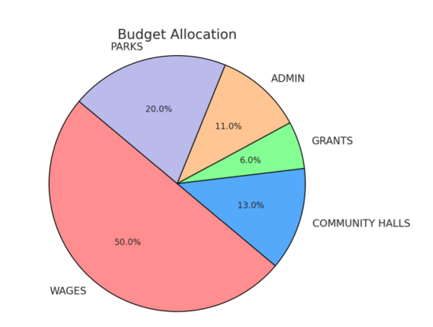
To give context to the figures shown, the areas are broken down to include the following (lists are not exhaustive):

Parks and Community Spaces
Footpaths and Bridleway maintenance
Cwm Du Nature Reserve
Highway seating and litterbins
Hanging baskets and Town Floral decorations
Christmas Lights
Defibrillators

Governance
General Administration
Management of Town Council functions and finance
Support and advice at Town Council meetings
Implementation of Council decisions and organisation of Council procedures
HR Functions

Insurance
Health and Safety
Organisation of Civic Functions and other events
Research and implementation of grant funding
Liaison with Partners and other groups
Media and Social Media
Grants for local groups and Partnership events

Community Halls
Liaison with Community Hall Management Committees
Insurance/ Risk Assessments/ maintenance/ advice

Wages
Staff wages together with tax and pension contributions

Supporting Wellbeing in Pontardawe
Pontardawe Town Council places community wellbeing at the heart of all the decisions made and works to support both the Welsh Government Well-being of Future Generations Act and the Neath Port Talbot Public Service Board well-being objectives.

The Well-being of Future Generations (Wales) Act 2015 requires public bodies in Wales to think about the long-term impact of their decisions, to work better with people, communities and each other, and to prevent persistent problems such as poverty, health inequalities and climate change.

The Neath Port Talbot Public Services Board is made up of four statutory member organisations: Swansea Bay University Health Board, Neath Port Talbot County Borough Council, Natural Resources Wales and Mid and West Wales Fire and Rescue Service. The Board also invites a number of other partners to participate in its activity as ‘invited participants’. The Neath Port Talbot Public Service Board Objectives for 2023-28 are:

Well-being Objective 1: All children have the best start in life
Well-being Objective 2: All our communities will be thriving and sustainable
Well-being Objective 3: Our local environment, culture and heritage can be enjoyed by future generations
Well-being Objective 4: There are more green, secure and well-paid jobs and skills across the area

The table below outlines how Pontardawe Town Council achieves against these four objectives.

Pontardawe Town Council Project or Activity | Well-being Objective 1 –  Children and young people | Well-being Objective 2 – Thriving Communities | Well-being Objective 3 –  Environment, Culture & Heritage | Well-being Objective 4 –  Employment & Skills
Improving the Town Centre experience for visitors and local people (e.g floral displays, Christmas decorations, flags at key points of the season. | ✔️ | ✔️ | ✔️ | ✔️
Financially supporting family focussed events and festivals in the town such as the Pontardawe Winterfest, the King George V Park fete and St Peter’s Flower Festival. | ✔️ | ✔️ | ✔️ | ✔️
Providing Community Halls free of charge to Youth Clubs in Ynysmeudwy and Trebanos | ✔️ | ✔️ | ✔️ | ✔️
Councillors act as Minor Authority Governors at local Primary and Secondary Schools | ✔️ | ✔️
Children’s activity groups well represented at all three Community Halls | ✔️ | ✔️
Well maintained and adventurous play equipment at all three parks | ✔️ | ✔️ | ✔️
Grant funding support for local sports, wellbeing, heritage, cultural and environmental groups | ✔️ | ✔️ | ✔️ | ✔️
Financing the Crossing Support Officer for Swansea Road adjacent to Cwmtawe School | ✔️ | ✔️ |  | ✔️
Annual co-option of Youth Councillors to ensure diversity and the voice of the town’s youth is heard | ✔️ | ✔️ |  | ✔️
Partnership working on events with the Arts Centre, Chamber of Commerce, Pontardawe Heritage Centre, Menter Iaith Castell-nedd Port Talbot and others | ✔️ | ✔️ | ✔️ | ✔️
Installation of CCTV in the town centre in partnership with Neath Port Talbot Council |  | ✔️ |  | ✔️
Participation in the creation of the Neath Port Talbot Place Plan for Pontardawe, in conjunction with ‘The Urbanists’ | ✔️ | ✔️ | ✔️ | ✔️
Acting as guardian of several defibrillators within the Town Council area |  | ✔️
Support for the Pontardawe Twinning Events with Locminé and the signing of the Catasauqua Friendship agreement | ✔️ | ✔️ | ✔️ | ✔️
Support for the Friends of King George V Park project to refurbish the derelict tennis courts. | ✔️ | ✔️ | ✔️ | ✔️
Management of part of the Cwm Du Nature Reserve |  | ✔️ | ✔️
Creation of a Street Art Heritage Trail on Openreach boxes and benches within the town |  | ✔️ | ✔️
Liaison and grant funding for a range of environmentally-focussed volunteer groups e.g. My Green Valley, Pontardawe Conservation Volunteers and Pontardawe Repair Cafe |  | ✔️ | ✔️ | ✔️
Support of small businesses and community enterprises such as the Pontardawe Hwb and wellbeing space |  | ✔️ |  | ✔️
Mayor and Councillors liaison with local business owners to identify and address issues. |  | ✔️ |  | ✔️
Encouraging business within the Town Centre with one-hour free parking |  | ✔️ |  | ✔️
Encouraging start-ups by supporting a thriving Town Centre which is a pleasure to visit |  | ✔️ |  | ✔️

Addressing the goals of The Well-being of Future Generations Act (2015)

There are 7 connected well-being goals for Wales. They are:

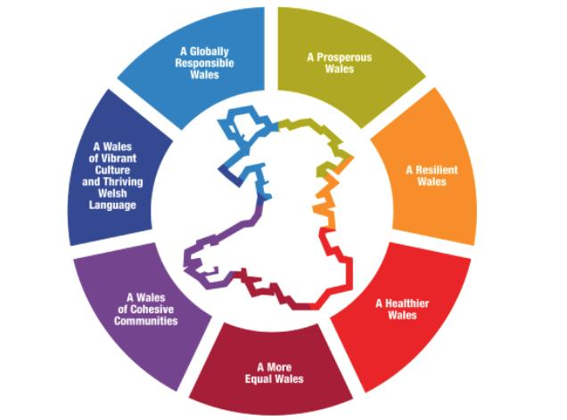

Pontardawe Town Councils works to address these goals through its business-as-usual activities but also through instigating and leading a range of different activities and projects, often in partnership with other bodies and societies.

There continues to be a cost-of-living crisis for many and while the Town Council does not have direct control over social services, education or housing, it does work closely with the County Borough, to ensure that issues at a local level are efficiently reported, via our County Borough Members, who are all also Town Councillors.

Over the past year, the Town Council maintained parks provided free entertainment for young people and our Community Halls are heavily subsidised to enable them to be run as community assets rather than as a source of revenue. With costs for group activities and one-off events, such as children’s parties being very reasonably priced.

By providing outdoor space at Parc Chwarae Teg in Rhyd-y-Fro, in Ynysmeudwy and at Trebanos Park, the Council is committed to supporting the health of residents in the Pontardawe area. The Council ensures that the parks are regularly maintained and safe for use by the public. Parc Chwarae Teg is a children’s play area and MUGA. Trebanos Park encompasses both the Rugby ground and changing rooms (these are leased to Trebanos Rugby Club) and a children’s play area. Ynysmeudwy Park holds a children’s play area, MUGA and supports an environmental project to plant trees, create bug and bird boxes and to maintain a meadow area. We are also working in partnership with Neath Port Talbot Council to refurbish the derelict tennis courts at King George V Park.

The Town Council works in partnership with the Neath Port Talbot Town Centre Officer, the Pontardawe Arts Centre, Chamber of Commerce, Pontardawe Heritage Centre and Menter Iaith Castell-nedd Port Talbot, alongside others, to promote the Town and to organise festivals and events to encourage footfall to the area. The Town Council also financially support through the grants process, in total or in part, a number of events and activities within Pontardawe. These include fireworks, the Tree of Light, carnivals, Christmas events, fetes, food festivals and town centre flags. Working together with our County Borough Members, the Royal British Legion and Pontardawe Veterans, the Town Council has led on discussions and arrangements during 2024 to deliver future Remembrance events following changes to regulations on organising public memorial events alongside highways.

The Town Council is committed to the development of young people in the area and have provided the second hall area at Ynysmeudwy as a permanent home for the Youth club, free of charge. It has also supported the creation of a new Welsh Language Youth Club in Trebanos Hall. Town Council grants (both capital and revenue) are available for local groups and organisations to assist with their costs.

Pontardawe Town Council is committed to ensuring that the town remains a pleasant, clean and safe environment. To further aid this aim, in 2024-25 we worked alongside Neath Port Talbot Council and the local Police Force to install a CCTV system which provides a 24/7 ‘live’ feed from Pontardawe Town Centre. Councillors consider monthly reviews of Police statistics at the Ordinary General meeting and receive monthly reports from County Borough Members on both high level and local actions. The Town Council is also a supporter of Dementia Friendly Communities and is guardian for several Defibrillators, all of which are connected to the Circuit. Pontardawe Town Council also financially supports the Crossing Patrol Officer at Swansea Road in conjunction with Cwmtawe School and Neath Port Talbot Council to ensure our young people reach their school safely.

Pontardawe Town Council is not responsible for any highways or street cleaning; however, we have developed excellent working relationships with the responsible authority. Street Cleaning, litter collection, refuse and recycling are the responsibility of Neath Port Talbot Council but colleagues on the Town Council can support these services in reporting and addressing areas of concern. The Town Council has also provided some litter bins within Pontardawe together with additional highway seating. Grants have also been provided to My Green Valley to assist in volunteer litter picks.

The Town Council acts as consultee on Planning matters and observations are then made to the Local Planning Authority on any issues which are perceived to be a detriment to the town.

Town Councillors are also liaising with Neath Port Talbot Council and The Urbanists to support the Town Team Project which aims to create a Community and Place Plan to future-proof and support both the retail park, Town Centre and the Industrial Estate through supplementary planning. The Town Council also monitors the unused County Borough buildings such as the Cross and Gelligron House and actively engages in discussions on means of bringing these assets back into community use.

Town Councillors are also present on various liaison committees to support both business and the environment in the local area (i.e. Pwllfawatkin liaison and Gwrhyd Quarry Liaison)
The Town Council has an Environmental Statement which was created in under the Environment (Wales) Act 2016 to maintain and enhance biodiversity and was updated in 2022.

The Town Council supports the Welsh language in a range of ways. We have recently supported the creation of a Welsh Language Youth Club at Trebanos Hall, in partnership with NPT Youth Services. We promote bilingualism with a bilingual website and we have partnered with Menter Iaith Castell-nedd Port Talbot on several projects and events that promote the use of the Welsh language. Tŷ'r Gwrhyd, the Pontardawe Welsh Language Centre, is located on Holly Street in Pontardawe and supports the Council's activities, including the Pontardawe Repair Cafe. Our Councillors are Minor Authority Governors at YGG Trebannws and YGG Pontardawe. Grants have been provided to both the Urdd Gobaith Cymru and the National Eisteddfod. Pontardawe Town Council is also included within the institute of Welsh Affairs ‘Understanding Welsh Places’ project.

The Town Council also sources grant income from other bodies in order to improve the community in various ways. This year we specifically focussed on heritage and the environment and succeeded in capturing a grant from the National Lottery Heritage Fund managed by Neath Port Talbot County Council and a Neath Port Talbot Local Nature Partnership Biodiversity Grant.

Our heritage street art project enabled cross-generational collaboration to share views and information that helped us highlight landmarks, individuals, and other elements of our heritage, that reflect and make Pontardawe’ s culture visible to residents and visitors alike. The Project provided visually stunning artwork on Openreach boxes and benches that have stimulated discussion and enhanced the appearance of the town.

Our Biodiversity Project allowed 1.5 kms of invasive rhododendrons to be treated by specialist contractors. Over time this will reduce the canopy and allow native species to recolonise the area. Volunteer days will also be arranged to address smaller infestations and to encourage community engagement in the area. The Grant also provided bird and bat boxes at Cwm Du. It provided training for conservation volunteers in surveying techniques, and the use of the bat detector equipment. The work will now allow the group to organise volunteer days to survey the Bats, once they are out of hibernation.

As well as sourcing grants, the Town Council also provides grants for local groups, working in partnership to ensure funding for a variety of local groups. Over £13,000 was provided in grant income to these groups during 2024/25 to help all ages and to support both revenue and capital project.

Grants Awarded by Pontardawe Town Council 2024-25:

Pontardawe Conservation Volunteers | £1800
Pontardawe Twinning Association | £300
Pontardawe Senior Citizens | £500
Friends of King George V Park | £500
Mama’s Academy | £500
Pontardawe Pride | £50
Pontardawe Heritage Centre | £1000
Pontardawe Cricket Club | £500
Pontardawe Clothes Swap | £484.80
Glantawe Lions | £150
Swansea Valley rugby | £395
Pontardawe AFC | £500
Pontardawe Rec Association | £1000
Pontardawe Community Hub | £3000
Empower Inspire CIC | £400
Menter Iaith Castell-nedd Port Talbot | £100
Pontardawe RFC | £1800
National Eisteddfod of Wales | £160.10
Eisteddfod yr Urdd Dur a Môr Margam 2025 | £160.10
TOTAL | £13,300

At a glance - Council Achievements in 2024/25
- Summer floral display within the Pontardawe Town Centre and a planter at Trebanos and Rhyd-y-Fro
- Pontardawe Winterfest – Christmas tree and lights, a fancy-dress competition and fireworks to celebrate, and a Christmas Festive Town Centre window competition
- Easter Events at the parks and a family fun day at Rhyd-y-Fro
- Heritage Street Art project to improve the town’s image and highlight key landmarks and aspects of the town’s history and heritage funded by the National Lottery Heritage Fund grant from Neath Port Talbot County Council
- Heritage Trails to encourage residents and visitors to enjoy the area’s walking paths and heritage sites funded by the National Lottery Heritage Fund grant from Neath Port Talbot County Council
- Management of Cwm Du Nature Reserve including addressing ash dieback and to reinstate the circular path
- Volunteer days to improve our natural surroundings and encourage a sense of community
- A Civic Event to celebrate the contributions of volunteers in our community and to mark a decade since the opening of the PANTRY foodbank.
- Continued support of the Pantry foodbank, the Repair Cafe and two youth clubs
- Representing community views on key developments or changes afoot in Pontardawe, from the need to replace the swimming pool, to the planning application by MacDonalds and the future of The Cross.
- Continuous improvements of our Community Halls and children’s play areas
- Employment of a Swansea Road Crossing Patrol Officer
- Working with NPT Council and The Urbanists to develop a Community Plan
- Engaging with a variety of Welsh Government consultations
- Liaison with the Royal British Legion and Neath Port Talbot Council to identify a way forward for future Remembrance events at Pontardawe War Memorial
- Support for the 2025 National Urdd Eisteddfod at Margam Park
- Support for local societies, groups and clubs who work to improve the lives of the residents of Pontardawe

A Year in Pictures

