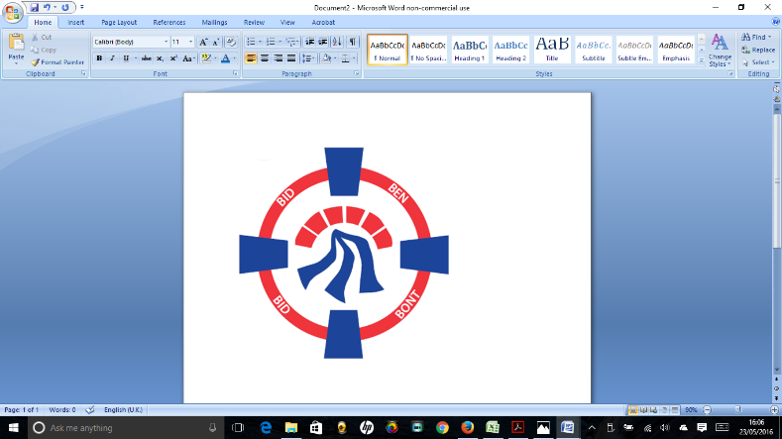

Cyngor Tref Pontardawe Town Council

Grant Project Completion Statement

Following agreement of the Completion statement by the Town Council, each Organisation may submit further grant applications.

Name of Organisation

Name and address of contact

Telephone & Email address

Project Completion date

Amount of Grant Awarded

Capital Grant of over £1000 – Have you included receipts YES/NO/ Not applicable.

Revenue Grant of over £1000 – Have you included a list of purchases made to the value of the grant? YES/NO/ Not applicable.

Have you included reference to the grant in your Media/Social Media YES/NO

Have Photographs/ social media links been provided for use by the Town Council in Town Council sponsored media YES/NO

Any other information relevant to the Project

**Signed & Dated**

Please add additional sheets if necessary