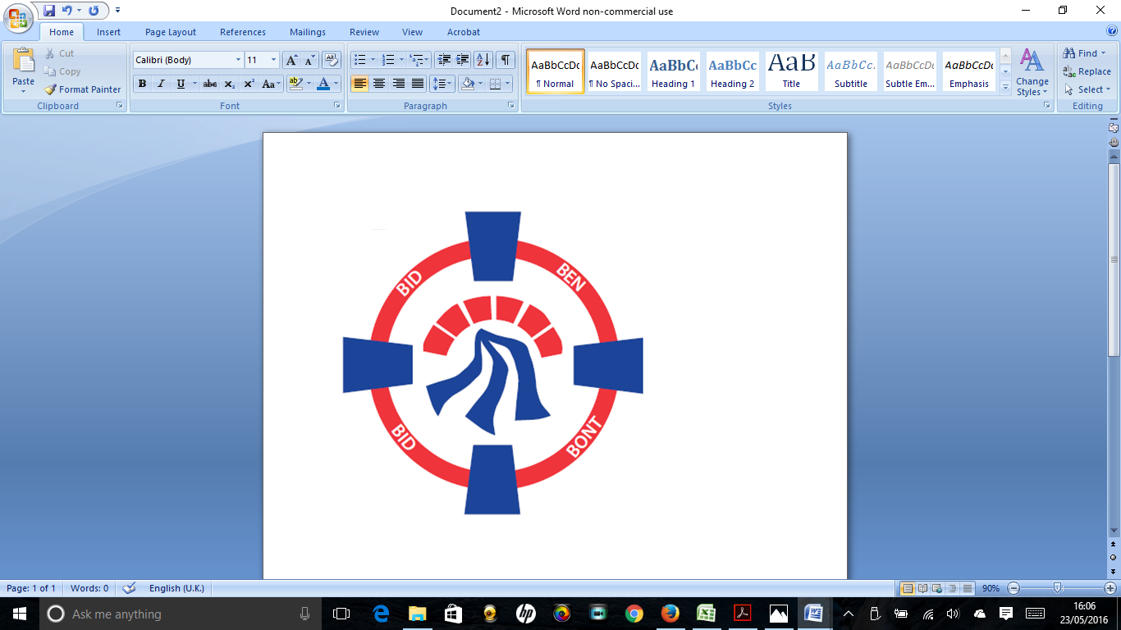

Pontardawe Town Council, Office 2, 2nd floor, Pontardawe Arts Centre, Herbert Street, Pontardawe SA84ED

Email: [town.clerk@pontardawetowncouncil.gov.wales](mailto:town.clerk@pontardawetowncouncil.gov.wales)

Telephone 07827972226

6th January 2025

Dear Councillor

I wish to inform you that there will be an Ordinary General Meeting on 13th January 2025. A Hybrid facility will be available. The physical meeting will take place at the Gallery, 2nd Floor, Pontardawe Arts Centre, Herbert Street, Pontardawe SA8 4ED. There will also be access via the virtual platform Zoom. The meeting will commence at 6.45pm

I trust that you will be able to attend.

Yours faithfully / Yn gywir

D. Phillips 

Town Clerk / Clerc y Dref

**Agenda**

**1.** Apologies for absence.

**2.** Disclosure of personal and pecuniary interest in items of business listed below.

**3.** Signing of the minutes of previous Ordinary Meeting held on the 9th December 2024**.**

**4.** To consider matters raised by members of the public (N.B such matters will be

reported upon by the Town Clerk at the next meeting, where appropriate)

**5. Matters arising:**

12675 **-** Police Matters – Clerk to provide details from the ‘Our Bobby’ web site.

12676 - Monthly update from Neath Port Talbot County Borough Council Members

12677 – Grant Applications and letters of thanks

12678 – Eco & Wellbeing – project updates

12680 – Significant Closures (Pontardawe Swimming pool, The Cross Community Centre and Gelligron House)

12681 – Welcome to Trebanos/Croeso I Drebannws sign

12682 – Place Plans /The Urbanists

12683 – Remembrance

12684 - Parks

12693- Flower Display 2025

**6. Reports**

Planning including updates

Clerks report re damage due to storm Darragh (December 2024)

**7. Accounts Schedule** 421totalling £27346.53 together with Bank reconciliation and Budget/Actual statement for quarter 3

**8. Correspondence**

* None

**9. Open Consultations relating to the public sector – Links on the Members area of the Website:**

**None**

**10. Urgent Road Safety Matters plus previous responses**

**11. Date of Next Ordinary Meeting**- To confirm that the next Ordinary meeting will be held on the 10th February 2025 with hybrid facilities. The physical meeting will be held at the Gallery, 2nd Floor, Pontardawe Arts Centre, Herbert Street, Pontardawe SA8 4ED with support from the virtual platform Zoom.