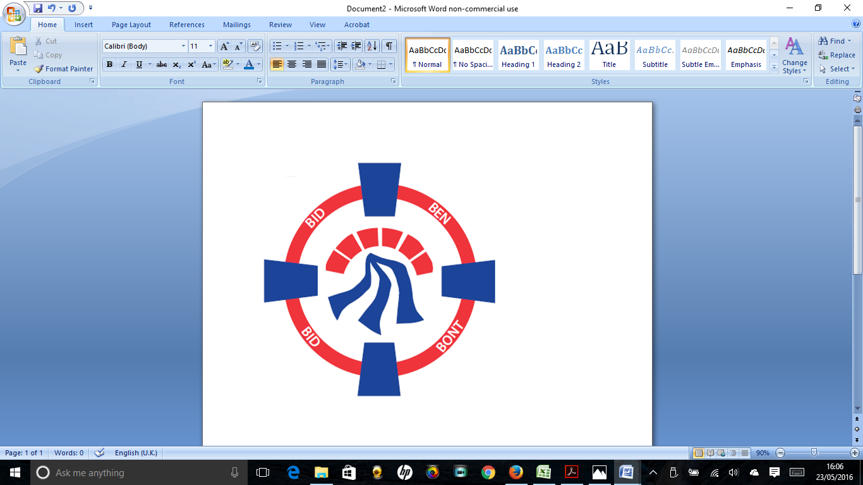

Pontardawe Town Council, Office 2, 2nd floor, Pontardawe Arts Centre, Herbert Street, Pontardawe SA84ED

Email: [town.clerk@pontardawetowncouncil.gov.wales](mailto:town.clerk@pontardawetowncouncil.gov.wales)

Telephone 07827972226

6th June 2023

Dear Councillor

I wish to inform you that there will be an Ordinary General Meeting on Monday 12th June 2023. A Hybrid facility will be available. The physical meeting will take place at the Gallery, 2nd Floor, Pontardawe Arts Centre, Herbert Street, Pontardawe SA8 4ED. There will also be access via the virtual platform Zoom. The meeting will commence following the Annual General meeting at 6.45pm

I trust that you will be able to attend.

Yours faithfully / Yn gywir

D. Phillips 

Town Clerk / Clerc y Dref

**Agenda**

**1.** Apologies for absence.

**2.** Disclosure of personal and pecuniary interest in items of business listed below.

**3.** Signing of the minutes of previous Ordinary Meeting and Annual General Meeting held on the 15th May 2023.

**4.** To consider matters raised by members of the public (N.B such matters will be

reported upon by the Town Clerk at the next meeting, where appropriate)

**5.** Presentation by Awel Aman Tawe re Green solutions

**6. Matters arising:**

12250– Defibrillator Mapping Project

12251 **-** Police Matters – Clerk to provide details from the ‘Our Bobby’ web site.

12252 - Monthly update from Neath Port Talbot County Borough Council Members

12253 – Grant Applications and letters of thanks

12254 – Eco & Wellbeing – project updates

12259 – Annual Report to the 31st March 2023

**7. Reports**

Planning including meeting on the 5th June 2023

Clerks Report on Community Halls and Caretakers retirement

Public Service Board Local Well-being Plan

Voter ID and the Elections Act 2022 - Information

**8. Accounts Schedule 404** totalling £17735.24 together with Bank Reconciliation.

**9. Correspondence**

* **Correspondence re James Street Chapel**
* **Letter received from Ombudsman**
* **Email received from Neath Port Talbot Council re joint working**
* **Email re LGBTQ+ Pride NPT**
* **Friends of Pontardawe Arts Centre**
* **Friends of King George V Park**
* **Email re Memorials**
* **Email re Publications**

**10. Open Consultations relating to the public sector – Links on the Members area of the Website:**

**None**

**11. Urgent Road Safety Matters plus previous responses**

**12. Date of Next Ordinary Meeting**- To confirm that the next Ordinary meeting will be held on the 10th July 2023 with hybrid facilities. The physical meeting will be held at the Gallery, 2nd Floor, Pontardawe Arts Centre, Herbert Street, Pontardawe SA8 4ED with support from the virtual platform Zoom.