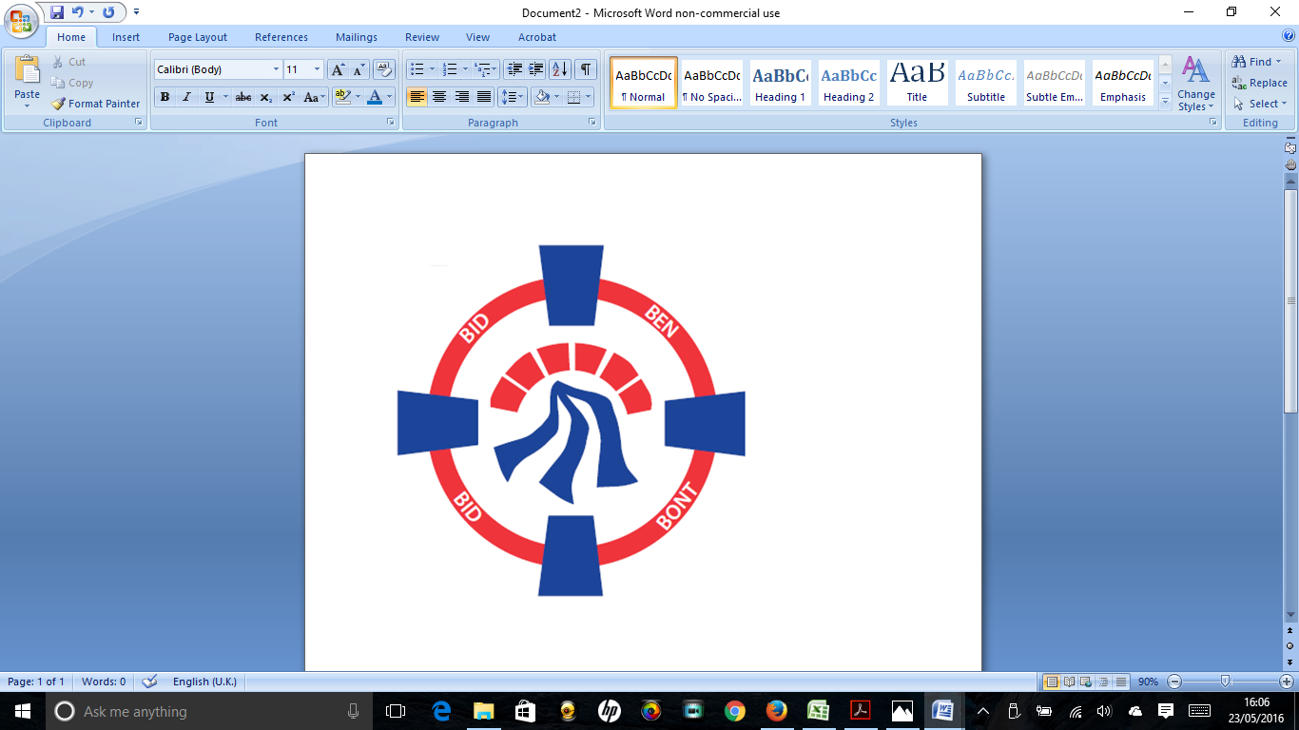

Pontardawe Town Council, Office 2, 2nd floor, Pontardawe Arts Centre, Herbert Street, Pontardawe SA84ED

Email: [town.clerk@pontardawetowncouncil.gov.wales](mailto:town.clerk@pontardawetowncouncil.gov.wales)

Telephone 07827972226

4th July 2023

Dear Councillor

I wish to inform you that there will be an Ordinary General Meeting on Monday 10th July 2023. A Hybrid facility will be available. The physical meeting will take place at the Gallery, 2nd Floor, Pontardawe Arts Centre, Herbert Street, Pontardawe SA8 4ED. There will also be access via the virtual platform Zoom. The meeting will commence following the Annual General meeting at 6.45pm

I trust that you will be able to attend.

Yours faithfully / Yn gywir

D. Phillips 

Town Clerk / Clerc y Dref

**Agenda**

**1.** Apologies for absence.

**2.** Disclosure of personal and pecuniary interest in items of business listed below.

**3.** Signing of the minutes of previous Ordinary Meeting on the 12th June 2023.

**4.** To consider matters raised by members of the public (N.B such matters will be

reported upon by the Town Clerk at the next meeting, where appropriate)

**5.** Presentation by Rachel Carter Local Places for Nature Officer & Riverside

**6. Matters arising:**

12273– Defibrillator Mapping Project

12274 **-** Police Matters – Clerk to provide details from the ‘Our Bobby’ web site, and update on the CAP Event

12275 - Monthly update from Neath Port Talbot County Borough Council Members

12276 – Grant Applications and letters of thanks

12277 – Eco & Wellbeing – project updates

12280 – Vacancy for Caretaker at Trebanos Hall

12291 - Publications

**7. Reports**

Planning

Model Standing Orders

Clerk Holidays

Pharmacy Update

Proposal for a Town Council Strategy over 1,3 and 5 years together with Councillor ‘walkabouts’ and visits to Community Halls

**8. Accounts Schedule 405** totalling £21565.76 together with Bank Reconciliation.

**9. Correspondence**

* Request for St David’s day flags
* Floral displays in Rhyd y Fro
* Request for Letters to Landlords re Herbert Street
* Request for alternative bins in Park

**10. Open Consultations relating to the public sector – Links on the Members area of the Website:**

**Noise and Soundscape plan for Wales 2023 to 2028**

**11. Urgent Road Safety Matters plus previous responses**

**12. Date of Next Ordinary Meeting**- To confirm that the next Ordinary meeting will be held on the 11th September 2023 with hybrid facilities. The physical meeting will be held at the Gallery, 2nd Floor, Pontardawe Arts Centre, Herbert Street, Pontardawe SA8 4ED with support from the virtual platform Zoom.