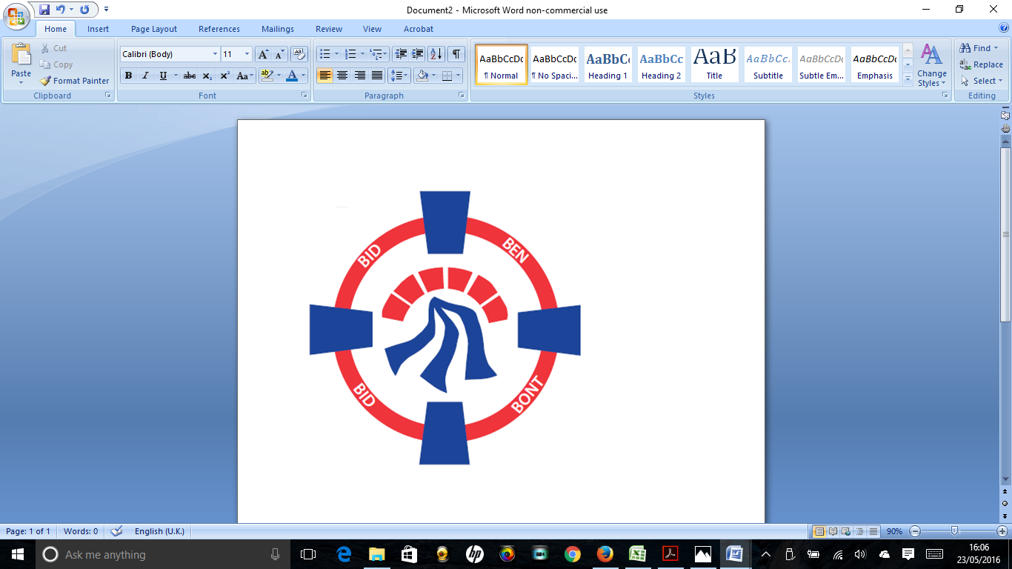

Pontardawe Town Council, Office 2, 2nd floor, Pontardawe Arts Centre, Herbert Street, Pontardawe SA84ED

Email: [town.clerk@pontardawetowncouncil.gov.wales](mailto:town.clerk@pontardawetowncouncil.gov.wales)

Telephone 07827972226

5th September 2023

Dear Councillor

I wish to inform you that there will be an Ordinary General Meeting on Monday 11th September 2023. A Hybrid facility will be available. The physical meeting will take place at the Gallery, 2nd Floor, Pontardawe Arts Centre, Herbert Street, Pontardawe SA8 4ED. There will also be access via the virtual platform Zoom. The meeting will commence following the Annual General meeting at 6.45pm

I trust that you will be able to attend.

Yours faithfully / Yn gywir

D. Phillips 

Town Clerk / Clerc y Dref

**Agenda**

**1.** Apologies for absence.

**2.** Disclosure of personal and pecuniary interest in items of business listed below.

**3.** Signing of the minutes of previous Ordinary Meeting on the 10th July 2023.

**4.** To consider matters raised by members of the public (N.B such matters will be

reported upon by the Town Clerk at the next meeting, where appropriate)

**5. Matters arising:**

12301 **-** Police Matters – Clerk to provide details from the ‘Our Bobby’ web site.

12302 - Monthly update from Neath Port Talbot County Borough Council Members

12303 – Grant Applications and letters of thanks

12304 – Eco & Wellbeing – project updates

12305 – Vacancy for Caretaker at Trebanos Hall

12311 – Town Planning

12313 – St David’s day flags

12315 – Lower Herbert Street – Landlord letters

12316 – Bins at Ynysmeudwy Park

**6. Reports**

Planning including meetings held on the 31.7.23 & 30.8.23

Clerks report – Youth Councillors

One Voice Wales representative

Clerks Report re Events

**7. Accounts Schedule 406 (July and August)** totalling £26062.79 together with Bank Reconciliation and Budget/Actual statement for Quarter 1

**8. Correspondence**

* Letter of Thanks
* Email re Pontardawe Primary Schools
* Email re Swimming Pool

**9. Open Consultations relating to the public sector – Links on the Members area of the Website:**

**Heat Strategy Wales** [**https://www.gov.wales/heat-strategy-wales**](https://www.gov.wales/heat-strategy-wales)

**Neath Port Talbot Draft Housing and Homelessness plan – See link**

**10. Urgent Road Safety Matters plus previous responses**

**11. Date of Next Ordinary Meeting**- To confirm that the next Ordinary meeting will be held on the 9th October 2023 with hybrid facilities. The physical meeting will be held at the Gallery, 2nd Floor, Pontardawe Arts Centre, Herbert Street, Pontardawe SA8 4ED with support from the virtual platform Zoom.