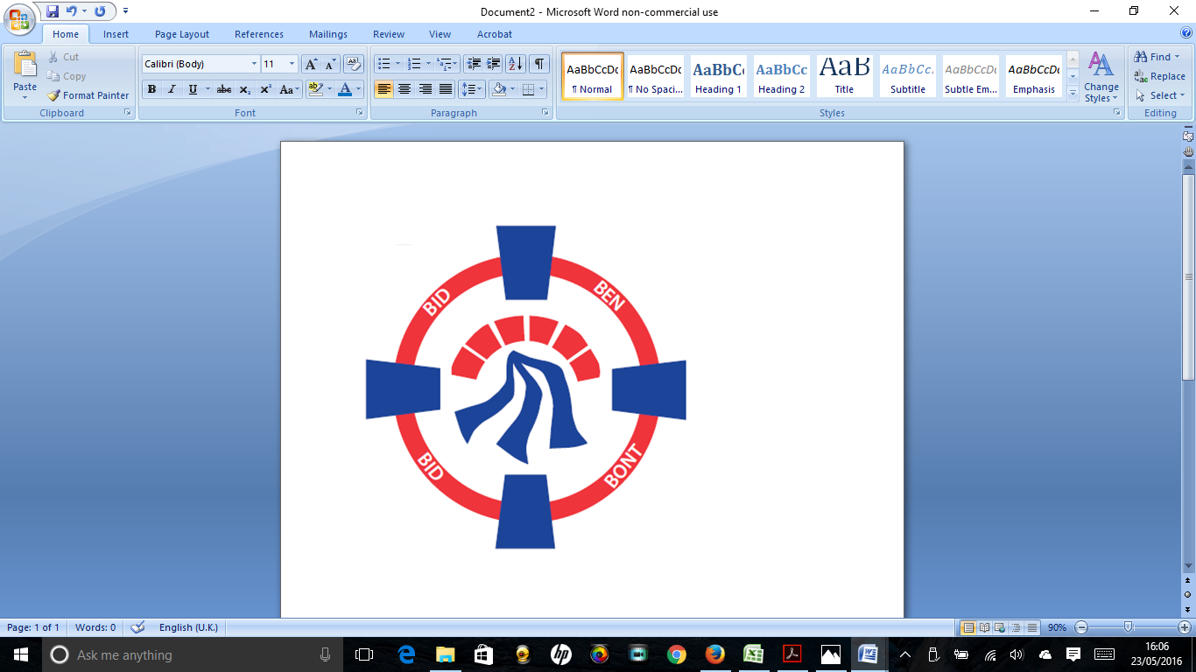

Pontardawe Town Council, Office 2, 2nd floor, Pontardawe Arts Centre, Herbert Street, Pontardawe SA84ED

Email: [town.clerk@pontardawetowncouncil.gov.wales](mailto:town.clerk@pontardawetowncouncil.gov.wales)

Telephone 07827972226

4th March 2025

Dear Councillor

I wish to inform you that there will be an Ordinary General Meeting on 10th March 2025. A Hybrid facility will be available. The physical meeting will take place at the Gallery, 2nd Floor, Pontardawe Arts Centre, Herbert Street, Pontardawe SA8 4ED. There will also be access via the virtual platform Zoom. The meeting will commence at 6.45pm

I trust that you will be able to attend.

Yours faithfully / Yn gywir

D. Phillips 

Town Clerk / Clerc y Dref

**Agenda**

**1.** Apologies for absence.

**2.** Disclosure of personal and pecuniary interest in items of business listed below.

**3.** Signing of the minutes of previous Ordinary Meeting held on the 10th February 2025**.**

**4.** To consider matters raised by members of the public (N.B such matters will be

reported upon by the Town Clerk at the next meeting, where appropriate)

**5. Matters arising:**

12719 **-** Police Matters – Clerk to provide details from the ‘Our Bobby’ web site.

12720 - Monthly update from Neath Port Talbot County Borough Council Members

12721 – Grant Applications and letters of thanks

12722 – Eco & Wellbeing – project updates

12723 – Significant Closures (Pontardawe Swimming pool, The Cross Community Centre and Gelligron House)

12725 – Place Plans /The Urbanists

12726 – Remembrance

12727 – Parks

12728 – Storm Darragh damage update

12730 – County Borough/Town Council Liaison Committee

12735 – Emergency Protocols

**6. Reports**

Planning Committee held on the 3rd March 2025

IRP 2025-26

Clerks report on the Blue Plaque scheme

Clerks report on Heol y Llwynau kick about area

**7. Accounts Schedule** 423totalling £19837.58 together with Bank reconciliation

**8. Correspondence**

* Letter of Resignation received
* One Voice Wales Membership 2025-26
* Safety of Lithium-ion Batteries
* Email received from Cefn Llan Residents association
* Email re Neath Port Talbot Council free parking survey

**9. Open Consultations relating to the public sector – Links on the Members area of the Website:**

**DBCC – Electoral Review Programme 2025 (deadline 24.3.25)**

**10. Urgent Road Safety Matters plus previous responses**

**11. Date of Next Ordinary Meeting**- To confirm that the next Ordinary meeting will be held on the 14th April 2025 with hybrid facilities. The physical meeting will be held at the Gallery, 2nd Floor, Pontardawe Arts Centre, Herbert Street, Pontardawe SA8 4ED with support from the virtual platform Zoom.