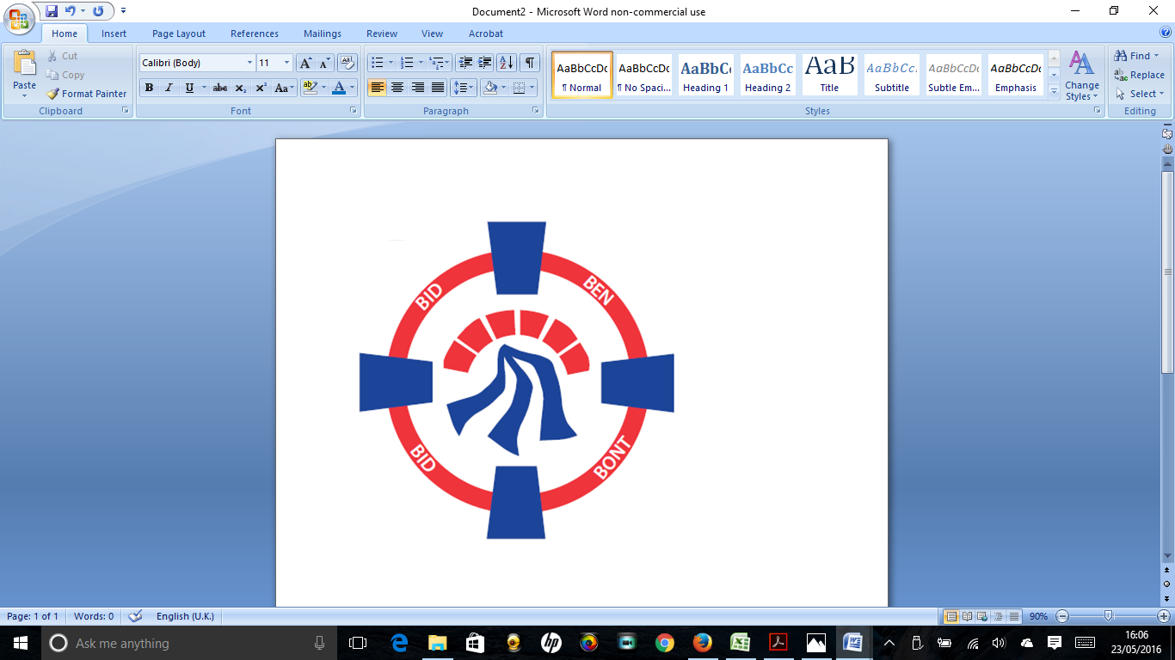

Pontardawe Town Council, Office 2, 2nd floor, Pontardawe Arts Centre, Herbert Street, Pontardawe SA84ED

Email: [town.clerk@pontardawetowncouncil.gov.wales](mailto:town.clerk@pontardawetowncouncil.gov.wales)

Telephone 07827972226

4th April 2025

Dear Councillor

I wish to inform you that there will be an Ordinary General Meeting on 14th April 2025. A Hybrid facility will be available. The physical meeting will take place at the Gallery, 2nd Floor, Pontardawe Arts Centre, Herbert Street, Pontardawe SA8 4ED. There will also be access via the virtual platform Zoom. The meeting will commence at 6.45pm

I trust that you will be able to attend.

Yours faithfully / Yn gywir

D. Phillips 

Town Clerk / Clerc y Dref

**Agenda**

**1.** Apologies for absence.

**2.** Disclosure of personal and pecuniary interest in items of business listed below.

**3.** Signing of the minutes of previous Ordinary Meeting held on the 10th March 2025**.**

**4.** To consider matters raised by members of the public (N.B such matters will be

reported upon by the Town Clerk at the next meeting, where appropriate)

5. Beth Parker Green Infrastructure Project Manager to address Council

**6. Matters arising:**

12745 **-** Police Matters – Clerk to provide details from the ‘Our Bobby’ web site.

12746 - Monthly update from Neath Port Talbot County Borough Council Members

12747 – Grant Applications and letters of thanks

12748 – Eco & Wellbeing – project updates

12749 – Significant Closures (Pontardawe Swimming pool, The Cross Community Centre and Gelligron House)

12750 – Place Plans /The Urbanists

12751 – Remembrance

12752 – Parks

12755 – Emergency Protocols

12758 – Blue Plaque Scheme

12761 – Trebanos Ward Vacancy

**7. Reports**

Planning

School Crossing Patrol Officer (Service Level Agreement)

Minor Authority Governor for YGG Trebannws

**8. Accounts Schedule** 424totalling £29051.94 together with Bank reconciliation and Budget/Actual report for the year end 2024/25

**9. Correspondence**

* Letter re Independent remuneration Panel
* Parking Issues at Home Bargains
* Email re Enhanced Public Safety

**10. Open Consultations relating to the public sector – Links on the Members area of the Website:**

CCR Draft Regional Transport plan

**11. Urgent Road Safety Matters plus previous responses**

**12. Date of Next Ordinary Meeting**- To confirm that the next Ordinary meeting and Annual General Meeting will be held on the 12th May 2025 with hybrid facilities. The physical meeting will be held at the Gallery, 2nd Floor, Pontardawe Arts Centre, Herbert Street, Pontardawe SA8 4ED with support from the virtual platform Zoom.