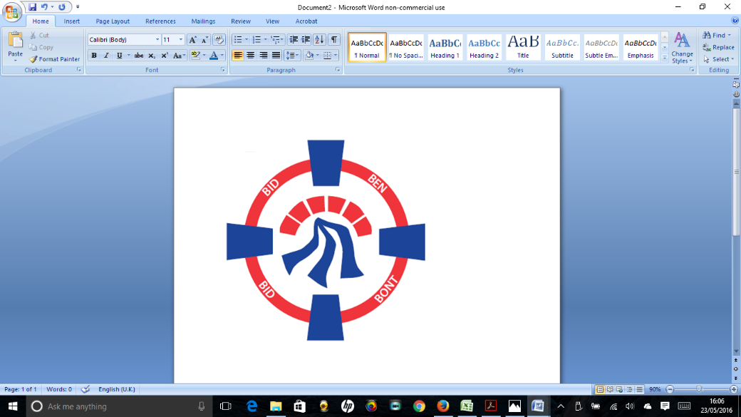

Pontardawe Town Council, Office 2, 2nd floor, Pontardawe Arts Centre, Herbert Street, Pontardawe SA84ED

Email: [town.clerk@pontardawetowncouncil.gov.wales](mailto:town.clerk@pontardawetowncouncil.gov.wales)

Telephone 07827972226

4th June 2025

Dear Councillor

I wish to inform you that there will be an Ordinary General Meeting on 9th June 2025. A Hybrid facility will be available. The physical meeting will take place at the Gallery, 2nd Floor, Pontardawe Arts Centre, Herbert Street, Pontardawe SA8 4ED. There will also be access via the virtual platform Zoom and will commence at 6.45pm

I trust that you will be able to attend.

Yours faithfully / Yn gywir

D. Phillips 

Town Clerk / Clerc y Dref

**Agenda**

**1.** Apologies for absence.

**2.** Disclosure of personal and pecuniary interest in items of business listed below.

**3.** Signing of the minutes of previous Ordinary Meeting and Annual General Meeting held on the 12thMay 2025**.**

**4.** To consider matters raised by members of the public (N.B such matters will be

reported upon by the Town Clerk at the next meeting, where appropriate)

5. Co-Option of Member for the Trebanos Ward Vacancy

**6. Matters arising:**

12823 **-** Police Matters – Clerk to provide details from the ‘Our Bobby’ web site.

12824- Monthly update from Neath Port Talbot County Borough Council Members

12825 – Grant Applications and letters of thanks

12826 – Eco & Wellbeing – project updates

12827 – Significant Closures (Pontardawe Swimming pool, The Cross Community Centre and Gelligron House)

12828 – Place Plans /The Urbanists

12829 – Remembrance

12830 – Parks

12832 – Blue Plaque Scheme

12834 – YGG Trebannws Minor Authority Governor vacancy

12838 – Annual Report

12842 – Dog waste bin adjacent to Rhyd y Fro Post Office

**7. Reports**

Planning

P&R Committee held on the 2nd June 2025 – Emergency Planning

Community Hall Report

Training Policy

**8. Accounts Schedule** 426totalling £14783.05. together with Bank reconciliation & Annual Insurance information

**9. Correspondence**

* Armed Forces week
* The Longest Yarn

**10. Open Consultations relating to the public sector – Links on the Members area of the Website:**

**Administration and Enforcement of Council Tax Consultation**

**11. Urgent Road Safety Matters plus previous responses**

**12. Date of Next Ordinary Meeting**- To confirm that the next Ordinary meeting will be held on the 14th July 2025 with hybrid facilities. The physical meeting will be held at the Gallery, 2nd Floor, Pontardawe Arts Centre, Herbert Street, Pontardawe SA8 4ED with support from the virtual platform Zoom.