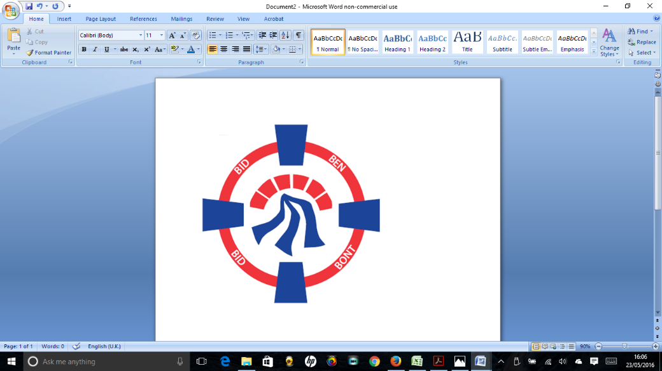

Pontardawe Town Council, Office 2, 2nd floor, Pontardawe Arts Centre, Herbert Street, Pontardawe SA84ED

Email: [town.clerk@pontardawetowncouncil.gov.wales](mailto:town.clerk@pontardawetowncouncil.gov.wales)

Telephone 07827972226

8th July 2025

Dear Councillor

I wish to inform you that there will be an Ordinary General Meeting on 14th July 2025. A Hybrid facility will be available. The physical meeting will take place at the Gallery, 2nd Floor, Pontardawe Arts Centre, Herbert Street, Pontardawe SA8 4ED. There will also be access via the virtual platform Zoom and will commence at 6.45pm

I trust that you will be able to attend.

Yours faithfully / Yn gywir

D. Phillips 

Town Clerk / Clerc y Dref

**Agenda**

**1.** Apologies for absence.

**2.** Disclosure of personal and pecuniary interest in items of business listed below.

**3.** Signing of the minutes of previous Ordinary Meeting held on the 9th June 2025**.**

**4.** To consider matters raised by members of the public (N.B such matters will be

reported upon by the Town Clerk at the next meeting, where appropriate)

**5. Matters arising:**

12851 **-** Police Matters – Clerk to provide details from the ‘Our Bobby’ web site.

12852- Monthly update from Neath Port Talbot County Borough Council Members

12853 – Grant Applications and letters of thanks

12854 – Eco & Wellbeing – project updates

12855 – Significant Closures (Pontardawe Swimming pool, The Cross Community Centre and Gelligron House)

12856 – Place Plans /The Urbanists

12857 – Remembrance

12859 – Blue Plaque Scheme

12862 – Dog waste bin adjacent to Rhyd y Fro Post Office

12864 – Emergency Planning

**6. Reports**

Planning

Conclusion of Audit to the 31st March 2024

Christmas 2025

Environment Wales Act – Section 6 Biodiversity Duty Report

One Voice Wales area committee report (11/6/25)

**7. Accounts Schedule** 427totalling £17455.37 together with Bank reconciliation and Budget/Actual Report for Quarter 1

**8. Correspondence**

* One Voice Wales constitution and Governance framework (see email)
* Pontardawe Conservation Volunteers
* Neath Port Talbot Council standards Committee Annual Report
* Letter from Mrs E Ranft re Trebanos Hall

**9. Open Consultations relating to the public sector – Links on the Members area of the Website:**

None

**10. Urgent Road Safety Matters plus previous responses**

**11. Date of Next Ordinary Meeting**- To confirm that the next Ordinary meeting will be held on the 8th September 2025 with hybrid facilities. The physical meeting will be held at the Gallery, 2nd Floor, Pontardawe Arts Centre, Herbert Street, Pontardawe SA8 4ED with support from the virtual platform Zoom – **There is no Ordinary General Meeting held in August**