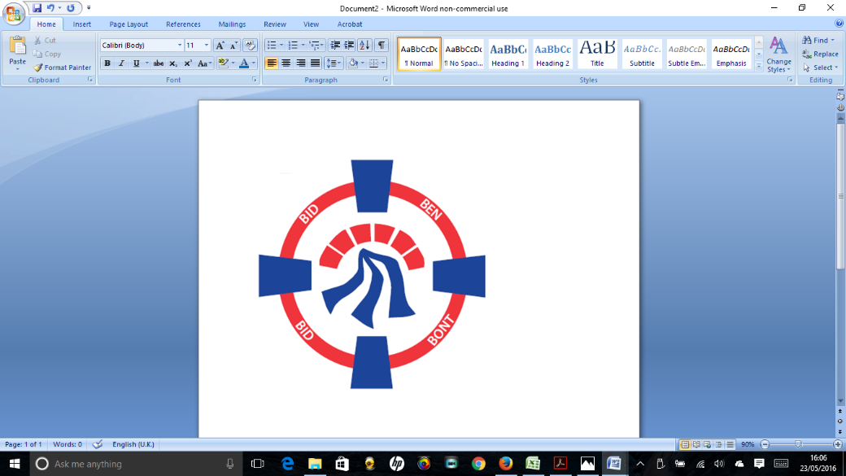

Pontardawe Town Council, Office 2, 2nd floor, Pontardawe Arts Centre, Herbert Street, Pontardawe SA84ED

Email: [town.clerk@pontardawetowncouncil.gov.wales](mailto:town.clerk@pontardawetowncouncil.gov.wales)

Telephone 07827972226

2nd September 2025

Dear Councillor

I wish to inform you that there will be an Ordinary General Meeting on 8th September 2025. A Hybrid facility will be available. The physical meeting will take place at the Gallery, 2nd Floor, Pontardawe Arts Centre, Herbert Street, Pontardawe SA8 4ED. There will also be access via the virtual platform Zoom and will commence at 6.45pm

I trust that you will be able to attend.

Yours faithfully / Yn gywir

D. Phillips 

Town Clerk / Clerc y Dref

**Agenda**

**1.** Apologies for absence.

**2.** Disclosure of personal and pecuniary interest in items of business listed below.

**3.** Signing of the minutes of previous Ordinary Meeting held on the 14th July 2025**.**

**4.** To consider matters raised by members of the public (N.B such matters will be

reported upon by the Town Clerk at the next meeting, where appropriate)

**5. Matters arising:**

12876 **-** Police Matters – Clerk to provide details from the ‘Our Bobby’ web site.

12877- Monthly update from Neath Port Talbot County Borough Council Members

12878 – Grant Applications and letters of thanks

12879 – Eco & Wellbeing – project updates

12880 – Significant Closures (Pontardawe Swimming pool, The Cross Community Centre and Gelligron House)

12881 – Place Plans /The Urbanists

12882 – Remembrance

12883 – Blue Plaque Scheme

12884 – Dog waste bin adjacent to Rhyd y Fro Post Office

12885 – Emergency Planning

12888 – Christmas 2025

12889 – Environment Wales Act – Section 6 Biodiversity duty report

12890 – One Voice Wales

**6. Reports**

Planning

Youth Councillors

Employment contract review & Local Government Services pay agreement for 2025/26

Crossing Patrol Officer / Swansea Road

**7. Accounts Schedule** 428totalling £42132.43 together with Bank reconciliation (two months for July & August 2025)

**8. Correspondence**

* Email received from Councillor Richards on behalf of a resident of Ynysmeudwy re Park
* Email re Armed Services Covenant
* Cwmtawe School Governor

**9. Open Consultations relating to the public sector – Links on the Members area of the Website:**

<https://www.gov.wales/extending-duty-local-authorities-broadcast-meetings>

<https://www.gov.wales/revisions-separate-collection-waste-materials-recycling-code-practice-wales>

**10. Urgent Road Safety Matters plus previous responses**

**11. Date of Next Ordinary Meeting**- To confirm that the next Ordinary meeting will be held on the 13th October 2025 with hybrid facilities. The physical meeting will be held at the Gallery, 2nd Floor, Pontardawe Arts Centre, Herbert Street, Pontardawe SA8 4ED with support from the virtual platform Zoom