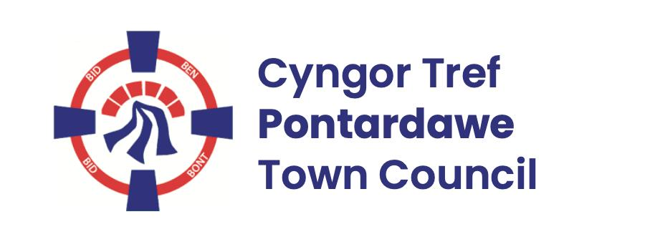
Pontardawe Town Council, Office 2, 2nd floor, Pontardawe Arts Centre, Herbert Street, Pontardawe SA84ED
Email: town.clerk@pontardawetowncouncil.gov.wales
Telephone 07827972226
4th November 2025

Dear Councillor
I wish to inform you that there will be an Ordinary General Meeting on 10th November 2025. A Hybrid facility will be available. The physical meeting will take place at the Gallery, 2nd Floor, Pontardawe Arts Centre, Herbert Street, Pontardawe SA8 4ED. There will also be access via the virtual platform Zoom and will commence at 6.45pm
I trust that you will be able to attend.

Yours faithfully / Yn gywir
D. Phillips
Town Clerk / Clerc y Dref

Agenda
1. Apologies for absence.
2. Disclosure of personal and pecuniary interest in items of business listed below.
3. Signing of the minutes of previous Ordinary Meeting held on the 13th October 2025.
4. To consider matters raised by members of the public (N.B such matters will be
reported upon by the Town Clerk at the next meeting, where appropriate)
5. Youth Councillor Co-Option
6. Matters arising:
12930 - Police Matters – Clerk to provide details from the ‘Our Bobby’ web site.
12931- Monthly update from Neath Port Talbot County Borough Council Members
12932 – Grant Applications and letters of thanks
12933 – Eco & Wellbeing – project updates
12934 – Significant Closures (Pontardawe Swimming pool, The Cross Community Centre and Gelligron House)
12935 – Place Plans /The Urbanists
12936 – Remembrance (overview)
12937 – Blue Plaque Scheme
12939 – Christmas 2025
12941 – Parks
12947 – community hall utilities report
12948 – One voice Wales meeting 4th November 2025
7. Reports
Planning including Planning Committee held on the 20th October 2025
Finance Committee held on the 20th October2025 to discuss the draft Budget and precept for 2026/27 (prior to review by Full Council)
Policy & Resources Committee held on the 20th October 2025 to discuss Armed Forces Covenants
St Davids Day grant report
Minor Authority Governor for Llangiwg School
8. Accounts Schedule 430 totalling £13803.33 together with Bank reconciliation for October 2025
9. Correspondence
- City and County of Swansea – Hanging basket scheme for 2026
- Letter re the Neath Port Talbot Council draft Licencing Act policy 2026-31
- SLCC – Membership renewal
10. Open Consultations relating to the public sector – Links on the Members area of the Website:
Consultation on the changes to local government elections rules in Wales
11. Urgent Road Safety Matters plus previous responses
12. Date of Next Ordinary Meeting- To confirm that the next Ordinary meeting will be held on the 8th December 2025 with hybrid facilities. The physical meeting will be held at the Gallery, 2nd Floor, Pontardawe Arts Centre, Herbert Street, Pontardawe SA8 4ED with support from the virtual platform Zoom

