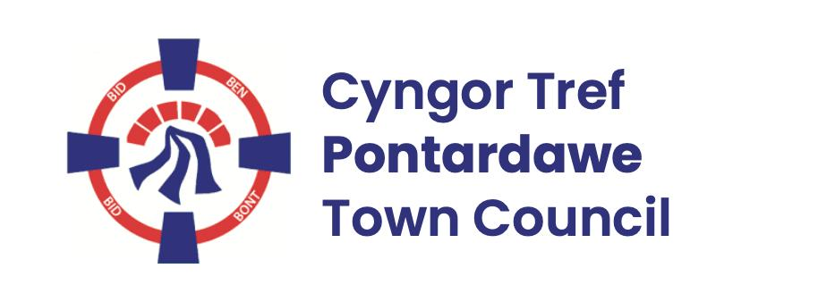
Pontardawe Town Council, Office 2, 2nd floor, Pontardawe Arts Centre, Herbert Street, Pontardawe SA84ED
Email: town.clerk@pontardawetowncouncil.gov.wales
Telephone 07827972226
2nd December 2025

Dear Councillor
I wish to inform you that there will be an Ordinary General Meeting on 8th December 2025. A Hybrid facility will be available. The physical meeting will take place at the Gallery, 2nd Floor, Pontardawe Arts Centre, Herbert Street, Pontardawe SA8 4ED. There will also be access via the virtual platform Zoom and will commence at 6.45pm
I trust that you will be able to attend.

Yours faithfully / Yn gywir
D. Phillips
Town Clerk / Clerc y Dref

Agenda
1. Apologies for absence.
2. Disclosure of personal and pecuniary interest in items of business listed below.
3. Signing of the minutes of previous Ordinary Meeting held on the 10th November 2025.
4. To consider matters raised by members of the public (N.B such matters will be
reported upon by the Town Clerk at the next meeting, where appropriate)
5. Matters arising:
12961 - Police Matters – Clerk to provide details from the ‘Our Bobby’ web site.
12962- Monthly update from Neath Port Talbot County Borough Council Members
12963 – Grant Applications and letters of thanks
12964 – Eco & Wellbeing – project updates
12965 – Significant Closures (Pontardawe Swimming pool, The Cross Community Centre and Gelligron House)
12966 – Place Plans /The Urbanists
12968 – Blue Plaques
12969 – Christmas 2025 (overview)
12974 – Draft Budget and Precept for 2026/27
6. Reports
Planning
Interim Auditors Report 25/26
External Audit Completion report 24/25
Trebanos Hall refurbishment
Awel Aman Tawe – Energy Efficiency reports
Clerks holiday
7. Accounts Schedule 431 totalling £27776.25 together with Bank reconciliation & Financial Service compensation scheme
8. Correspondence
- Email from the Royal British Legion re official feedback
9. Open Consultations relating to the public sector – Links on the Members area of the Website:
Neath Port Talbot Council – reorganisation of the ALN Provision
10. Urgent Road Safety Matters plus previous responses
11. Date of Next Ordinary Meeting- To confirm that the next Ordinary meeting will be held on the 12th January 2026 with hybrid facilities. The physical meeting will be held at the Gallery, 2nd Floor, Pontardawe Arts Centre, Herbert Street, Pontardawe SA8 4ED with support from the virtual platform Zoom

