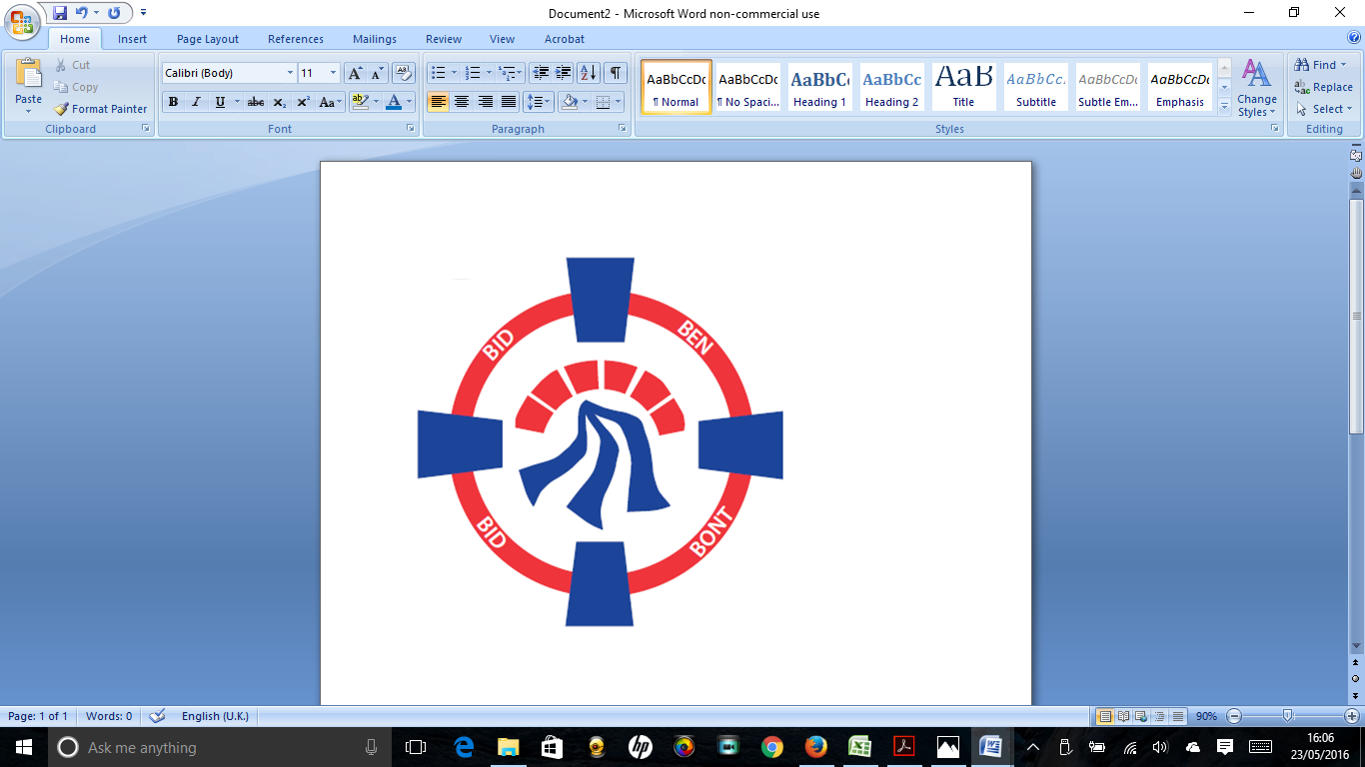

Pontardawe Town Council, Office 2, 2nd floor, Pontardawe Arts Centre, Herbert Street, Pontardawe SA84ED

Email: [town.clerk@pontardawetowncouncil.gov.wales](mailto:town.clerk@pontardawetowncouncil.gov.wales)

Telephone 07827972226

6th May 2025

Dear Councillor

I wish to inform you that there will be an Ordinary General Meeting on 12th May 2025. A Hybrid facility will be available. The physical meeting will take place at the Gallery, 2nd Floor, Pontardawe Arts Centre, Herbert Street, Pontardawe SA8 4ED. There will also be access via the virtual platform Zoom. The meeting will commence following the Annual General Meeting which begins at 6.45pm

I trust that you will be able to attend.

Yours faithfully / Yn gywir

D. Phillips 

Town Clerk / Clerc y Dref

**Agenda**

**1.** Apologies for absence.

**2.** Disclosure of personal and pecuniary interest in items of business listed below.

**3.** Signing of the minutes of previous Ordinary Meeting held on the 14th April 2025**.**

**4.** To consider matters raised by members of the public (N.B such matters will be

reported upon by the Town Clerk at the next meeting, where appropriate)

5. Elspeth Lowe (Brighter Futures) to address Council

**6. Matters arising:**

12773 **-** Police Matters – Clerk to provide details from the ‘Our Bobby’ web site.

12774 - Monthly update from Neath Port Talbot County Borough Council Members

12775 – Grant Applications and letters of thanks

12776 – Eco & Wellbeing – project updates

12777 – Significant Closures (Pontardawe Swimming pool, The Cross Community Centre and Gelligron House)

12778 – Place Plans /The Urbanists

12779 – Remembrance

12780 – Parks

12781 – Emergency Protocols

12782 – Blue Plaque Scheme

12783 – Trebanos Ward Vacancy

12786 – YGG Trebannws Minor Authority Governor vacancy

12789 – Parking at the Retail Park

**7. Reports**

Planning

Annual Return to 31.3.25 for review

Internal Auditors report for year to 31.3.25

Draft Annual Report to 31.3.25

Report – Terrorism (Protection of Premises Bill) – Martyn’s Law

Youth Councillors

**8. Accounts Schedule** 425totalling £36079.76. together with Bank reconciliation

**9. Correspondence**

* Letter re Dog waste bin
* Email & Letter from David Chadwick MP

**10. Open Consultations relating to the public sector – Links on the Members area of the Website:**

**None**

**11. Urgent Road Safety Matters plus previous responses**

**12. Date of Next Ordinary Meeting**- To confirm that the next Ordinary meeting will be held on the 9th June 2025 with hybrid facilities. The physical meeting will be held at the Gallery, 2nd Floor, Pontardawe Arts Centre, Herbert Street, Pontardawe SA8 4ED with support from the virtual platform Zoom.