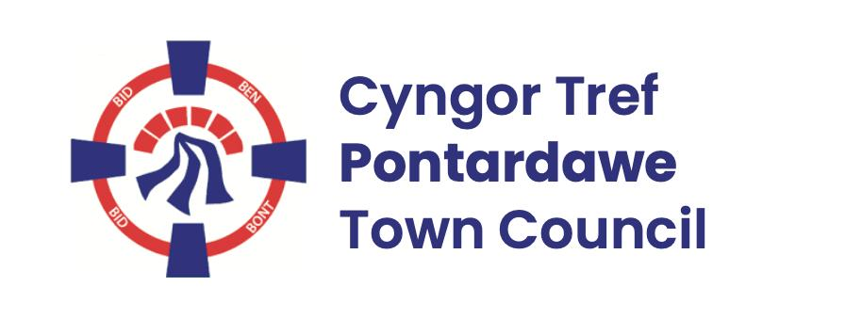
Pontardawe Town Council, Office 2, 2nd floor, Pontardawe Arts Centre, Herbert Street, Pontardawe SA84ED
Email: town.clerk@pontardawetowncouncil.gov.wales
Telephone 07827972226
6th January 2026

Dear Councillor
I wish to inform you that there will be an Ordinary General Meeting on 12th January 2026. A Hybrid facility will be available. The physical meeting will take place at the Studio, 1st Floor, Pontardawe Arts Centre, Herbert Street, Pontardawe SA8 4ED. There will also be access via the virtual platform Zoom and will commence at 6.45pm
I trust that you will be able to attend.

Yours faithfully / Yn gywir
D. Phillips
Town Clerk / Clerc y Dref

Agenda
1. Apologies for absence.
2. Disclosure of personal and pecuniary interest in items of business listed below.
3. Signing of the minutes of previous Ordinary Meeting held on the 8th December 2025.
4. To consider matters raised by members of the public (N.B such matters will be
reported upon by the Town Clerk at the next meeting, where appropriate)
5. Matters arising:
12989 – Trebanos Hall Refurbishment (including Extra Ordinary meeting held on the 15th December 2025 which included plenary powers)
12992 - Police Matters – Clerk to provide details from the ‘Our Bobby’ web site.
12993- Monthly update from Neath Port Talbot County Borough Council Members
12994 – Grant Applications and letters of thanks
12995 – Eco & Wellbeing – project updates
12996 – Significant Closures (Pontardawe Swimming pool, The Cross Community Centre and Gelligron House)
12997 – Place Plans /The Urbanists
12998 – Blue Plaques
6. Reports
Planning
Clerks report re Heol y Llwynau lease
Personnel Report (Confidential)
One Voice Wales meeting 10th December 2025
Utilities contracts
7. Accounts Schedule 432 totalling £23653.32 together with Bank reconciliation
8. Correspondence
- Email from the City and County of Swansea Pension re draft funding strategy
- CCTV Performance figures
- Email re the ‘Together we care Awards Ceremony’
- Email re future Christmas celebrations
- Email re Council tax base 2026/27
9. Open Consultations relating to the public sector – Links on the Members area of the Website:
None
10. Urgent Road Safety Matters plus previous responses
11. Date of Next Ordinary Meeting- To confirm that the next Ordinary meeting will be held on the 9th February 2026 with hybrid facilities. The physical meeting will be held at the Gallery, 2nd Floor, Pontardawe Arts Centre, Herbert Street, Pontardawe SA8 4ED with support from the virtual platform Zoom

