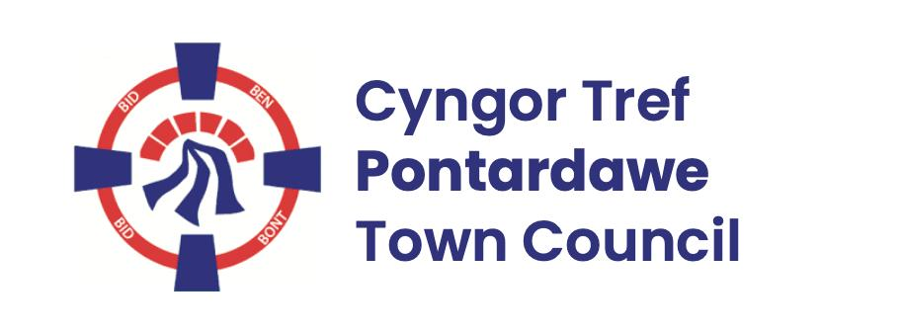
Pontardawe Town Council, Office 2, 2nd floor, Pontardawe Arts Centre, Herbert Street, Pontardawe SA84ED
Email: town.clerk@pontardawetowncouncil.gov.wales
Telephone 07827972226
3rd February 2026

Dear Councillor
I wish to inform you that there will be an Ordinary General Meeting on 9th February 2026. A Hybrid facility will be available. The physical meeting will take place at the Gallery, 2nd Floor, Pontardawe Arts Centre, Herbert Street, Pontardawe SA8 4ED. There will also be access via the virtual platform Zoom and will commence at 6.45pm
I trust that you will be able to attend.

Yours faithfully / Yn gywir
D. Phillips
Town Clerk / Clerc y Dref

Agenda
1. Apologies for absence.
2. Disclosure of personal and pecuniary interest in items of business listed below.
3. Signing of the minutes of previous Ordinary Meeting held on the 12th January 2026.
4. To consider matters raised by members of the public (N.B such matters will be
reported upon by the Town Clerk at the next meeting, where appropriate)
5. Matters arising:
13013 – Personnel (Including Panel – Plenary Powers provided)
13014 – Trebanos Hall Refurbishment
13015 - Police Matters – Clerk to provide details from the ‘Our Bobby’ web site.
13016- Monthly update from Neath Port Talbot County Borough Council Members
13017 – Grant Applications and letters of thanks
13018 – Eco & Wellbeing – project updates
13019 – Significant Closures (Pontardawe Swimming pool, The Cross Community Centre and Gelligron House)
13020 – Place Plans /The Urbanists
13021 – Blue Plaques
13023 – Heol y Llwynau
13024 – One voice Wales report
6. Reports
Planning
Public Procurement requirements
Parks/Footpath contract for 2026/27
7. Accounts Schedule 433 totalling £14095.52 together with Bank reconciliation and 3rd quarter Budget/Actual report
8. Correspondence
- Correspondence from Jeremy Miles MS
- Email re PAC Survey
- Email re Ethos Universitas Partner Communities
9. Open Consultations relating to the public sector – Links on the Members area of the Website:
Amendments to Extended Producer Responsibility for Packaging (pEPR)
10. Urgent Road Safety Matters plus previous responses
11. Date of Next Ordinary Meeting- To confirm that the next Ordinary meeting will be held on the 9th March 2026 with hybrid facilities. The physical meeting will be held at the Gallery, 2nd Floor, Pontardawe Arts Centre, Herbert Street, Pontardawe SA8 4ED with support from the virtual platform Zoom

