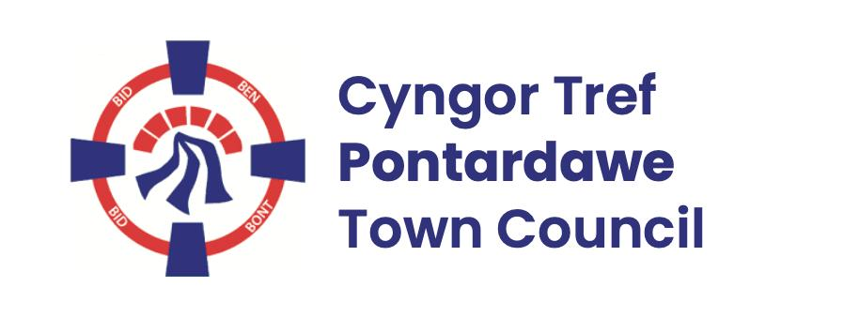
Pontardawe Town Council, Office 2, 2nd floor, Pontardawe Arts Centre, Herbert Street, Pontardawe SA84ED
Email: town.clerk@pontardawetowncouncil.gov.wales
Telephone 07827972226
3rd March 2026

Dear Councillor
I wish to inform you that there will be an Ordinary General Meeting on 9th March 2026. A Hybrid facility will be available. The physical meeting will take place at the Gallery, 2nd Floor, Pontardawe Arts Centre, Herbert Street, Pontardawe SA8 4ED. There will also be access via the virtual platform Zoom and will commence at 6.45pm
I trust that you will be able to attend.

Yours faithfully / Yn gywir
D. Phillips
Town Clerk / Clerc y Dref

Agenda
1. Apologies for absence.
2. Disclosure of personal and pecuniary interest in items of business listed below.
3. Signing of the minutes of previous Ordinary Meeting held on the 9th February 2026.
4. To consider matters raised by members of the public (N.B such matters will be
reported upon by the Town Clerk at the next meeting, where appropriate)
5. Matters arising:
13039 – Trebanos Hall Refurbishment
13040 - Police Matters – Clerk to provide details from the ‘Our Bobby’ web site.
13041- Monthly update from Neath Port Talbot County Borough Council Members
13042 – Grant Applications and letters of thanks
13043 – Eco & Wellbeing – project updates
13044 – Significant Closures (Pontardawe Swimming pool, The Cross Community Centre and Gelligron House)
13045 – Place Plans /The Urbanists
13046 – Blue Plaque
13047 – Heol y Llwynau
6. Reports
Planning
Clerks report re – Minimum wage
CCTV
Eisteddfod Cwm Tawe 2026
Remembrance 2026
Christmas 2026
Assertion 10 (Governance)
7. Accounts Schedule 434 totalling £45125.40 together with Bank reconciliation
8. Correspondence
- Correspondence re closed churchyards
- Democracy and Boundary Commission report 2026/27
- Email re planters
9. Open Consultations relating to the public sector – Links on the Members area of the Website:
None
10. Urgent Road Safety Matters plus previous responses
11. Date of Next Ordinary Meeting- To confirm that the next Ordinary meeting will be held on the 13th April 2026 with hybrid facilities. The physical meeting will be held at the Gallery, 2nd Floor, Pontardawe Arts Centre, Herbert Street, Pontardawe SA8 4ED with support from the virtual platform Zoom

