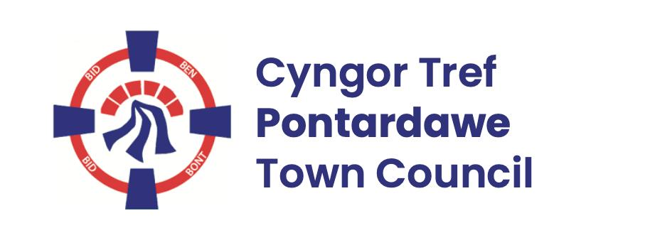
Pontardawe Town Council, Office 2, 2nd floor, Pontardawe Arts Centre, Herbert Street, Pontardawe SA84ED
Email: town.clerk@pontardawetowncouncil.gov.wales
Telephone 07827972226
7th April 2026

Dear Councillor
I wish to inform you that there will be an Ordinary General Meeting on the 13th April 2026. A Hybrid facility will be available. The physical meeting will take place at the Gallery, 2nd Floor, Pontardawe Arts Centre, Herbert Street, Pontardawe SA8 4ED. There will also be access via the virtual platform Zoom and will commence at 6.45pm
I trust that you will be able to attend.

Yours faithfully / Yn gywir
D. Phillips
Town Clerk / Clerc y Dref

Agenda
1. Apologies for absence.
2. Disclosure of personal and pecuniary interest in items of business listed below.
3. Signing of the minutes of previous Ordinary Meeting held on the 9th March 2026.
4. To consider matters raised by members of the public (N.B such matters will be
reported upon by the Town Clerk at the next meeting, where appropriate)
5. Matters arising:
13061 – Trebanos Hall Refurbishment
13062 - Police Matters – Clerk to provide details from the ‘Our Bobby’ web site.
13063- Monthly update from Neath Port Talbot County Borough Council Members
13064 – Grant Applications and letters of thanks
13065 – Eco & Wellbeing – project updates
13066 – Significant Closures (Pontardawe Swimming pool, The Cross Community Centre and Gelligron House)
13067 – Place Plans /The Urbanists
13068 – Blue Plaque
13072 – CCTV performance
13074 – Remembrance
13075 – Christmas 2026
6. Reports
Planning
Youth Representative
7. Accounts Schedule 435 totalling £27440.79 together with Bank reconciliation and Budget /Actual Report for the Year end, Internal Audit confirmation, and List of Direct Debits and Standing Orders for 2026-27
8. Correspondence
- Correspondence re dog waste
9. Open Consultations relating to the public sector – Links on the Members area of the Website:
None
10. Urgent Road Safety Matters plus previous responses
11. Date of Next Ordinary Meeting- To confirm that the next Ordinary meeting and Annual General Meeting will be held on the 11th May 2026 with hybrid facilities. The physical meeting will be held at the Gallery, 2nd Floor, Pontardawe Arts Centre, Herbert Street, Pontardawe SA8 4ED with support from the virtual platform Zoom

