Pontardawe Town Council
Annual Report 2025-26

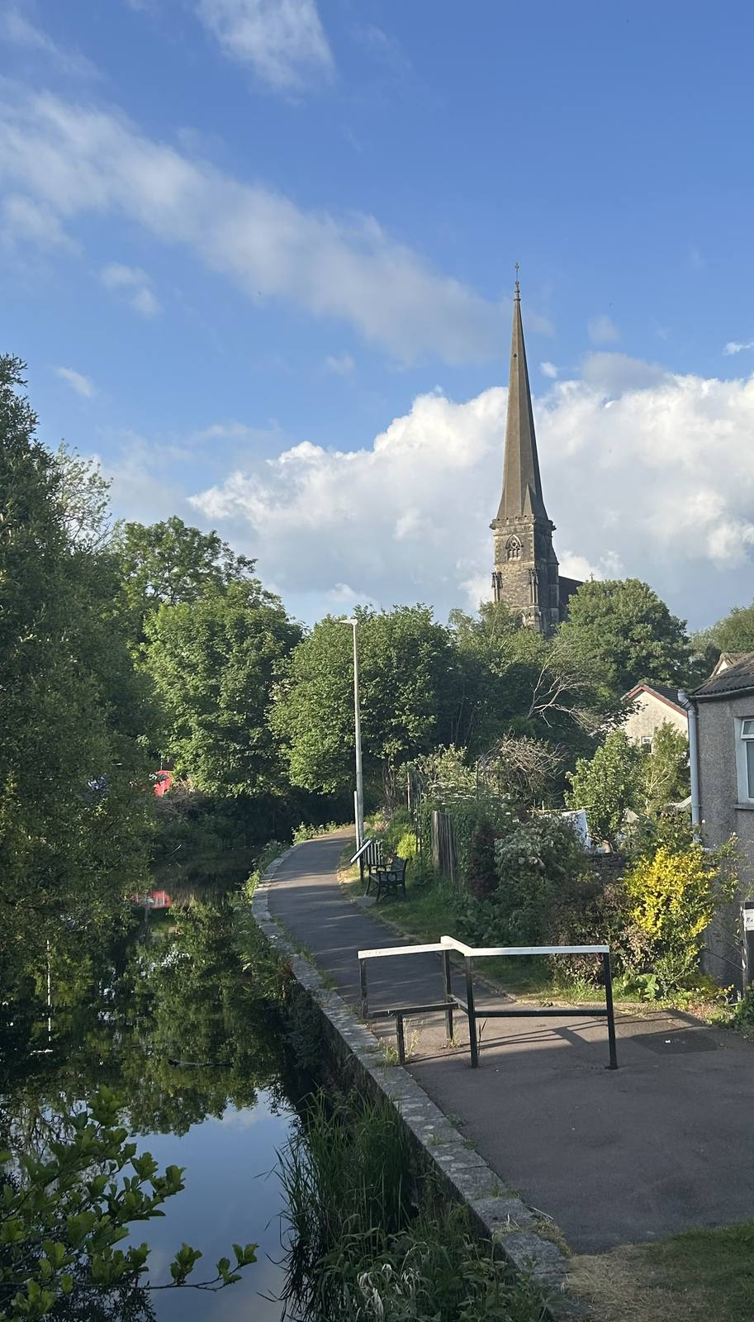

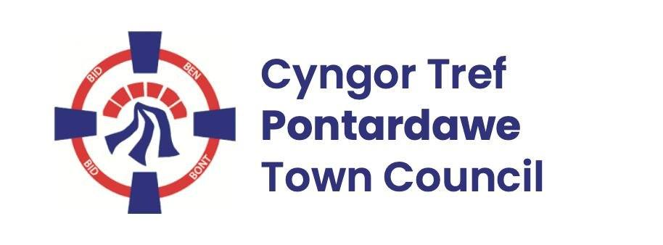

CONTENTS
Page

Mayor’s Foreword 3
Pontardawe 6
Pontardawe Town Council 8
Pontardawe Town Council Meetings, Decisions and Responsibilities 9
Pontardawe Town Councillors 11
Finance 15
Supporting Well-being in Pontardawe 19
Grants Awarded by Pontardawe Town Council 23
Achievements at a glance 24
A Year in Pictures 26

Mayor’s Foreword
It has been one of the greatest honours of my life to represent Pontardawe Town Council as Mayor during the past year. I would like to thank my fellow councillors for nominating and voting for me. It has been a wonderful privilege to see how many events and activities are taking place in our community and these need to be celebrated and applauded.
When I was first elected mayor, I stated that during my year in office, I wanted to continue to work with various groups in the community and to develop events in the community. It is a pleasure to present Pontardawe Town Council’s Annual Report 2025-2026 and to reveal that it has indeed been a very busy year for our community.
May 2025 saw the celebration and commemoration of VE day and the Royal British Legion organised an event at Pontardawe Rugby Club. For this event, I organised an art competition for all the local schools and the artwork produced by the pupils was exhibited on the day. It was a day of music, dancing and celebration but also a time to reflect on those who had given their lives in the Second World War. I was also interviewed on Radio Cymru prior to this event, and it was an honour to represent our town and share how we were commemorating VE Day.
The annual Pride event was held at the Gwachel in June. I was invited to judge the dog show which was a first for me! It was a joyous event which as usual showed Pontardawe at its best, celebrating inclusiveness and acceptance.
This event was followed by Armed Forces Day in late June. I raised the flag outside the Rugby Club to mark this occasion. Traditionally the flag is raised outside the Arts Centre but the building work on the new cinema was still taking place therefore it was necessary to change venues.
Early in June, our wonderful volunteers at the Heritage Centre hosted the ‘Longest Yarn ‘exhibition. We were honoured to host this in Pontardawe, the only other Welsh town hosting this exhibition was Brecon. A big thank you to the Heritage Centre for this coup, it is a unique knitted and crocheted exhibition telling the story of World War II through wool. The exhibition has been displayed across the UK, France and the US and now Pontardawe. I had the privilege of being interviewed by S4C for my views about the exhibition and how privileged we were to have it in Pontardawe.
The Heritage Centre has since displayed many exhibitions and held various craft events. As a Town Council we are pleased to sponsor many of these events and activities and I have been pleased to nominate the centre for the King’s Award for all the amazing work that all the volunteers do for our community.
July saw the Green Gathering at Glantawe Riverside. It brought together many diverse local businesses, organisations, groups and individuals all of whom have sustainability, the outdoors and wellbeing at their heart. It was a joy to see so many like-minded people together, sharing and showcasing their work with the public.
I have also had the honour of attending various charity events, such as the Cwmtawe Sevens Golf Day at Pontardawe Golf Club. These events would not happen if not for the hard work of a team of volunteers and of course the kind use of Pontardawe Golf course. The charity for this year was Adferiad Mental Health charity, and it was my pleasure to present the prizes to the winners of the competition.
Since being elected a Town Councillor, I have been Chair of the Friends of King George V Park group. We are very grateful to have our annual family fun day sponsored by Pontardawe Town Council. The Fun day which took place in August was combined with a celebration of VJ Day and this was held at Pontardawe Rugby Club. Various local singers, bands and up and coming dancers and musicians from the community entertained the guests. All money raised went to Scotty’s Little Soldiers. This is a military charity providing support for bereaved military children.
September saw my Civic Service at St Peters Church Pontardawe. I saw this as an opportunity to bring the community together to celebrate the efforts and hard work of all the groups of volunteers and individuals in our community. It is so important that their efforts should be celebrated and supported, through bringing people together for an official ceremony of appreciation, followed by a delicious afternoon tea provided by the Committee of St Peters Church.
The afternoon was a great success with over 100 people attending. The event also raised over £500 for the Mayor’s charity appeal namely Coeliac Wales.
The new Cinema at Pontardawe Arts Centre opened in October and it was my great honour to attend the official opening ceremony. The cinema has proved to be a great asset to our community, and I was very privileged to attend this event.
The Poppy Appeal dinner at Pontardawe Golf Club was the first of the Royal British Legion events that I attended, leading to the Remembrance Parade in November. The Pontardawe Branch of the RBL is one of the most active branches in Wales and their hard work meant that they raise thousands of pounds every year for the poppy appeal. It was rewarding to see that the Remembrance parade has been restored to Pontardawe. The parade which was held on November 9th was organised by Pontardawe Town Council in conjunction with the Pontardawe branch of the British Legion, it was attended by veterans, cadets and representatives of schools and local organisations and clubs.
The annual Winterfest event was my next official engagement and as usual this was a joyous event which brought the community together in a festive pre-Christmas celebration.
In February 2026 the first Cwmtawe Eisteddfod was held at Pontardawe Arts Centre. Pontardawe Town Council helped with some sponsorship of the event, but it could not have happened without the additional fund raising and organisation by the volunteers involved with this event. The day was a great success, and we look forward to the continuation of the eisteddfod in the future as a permanent annual event. It is with this in mind that I donate £200 from the Pontardawe Mayor’s charity to further support and promote Eisteddfod Cwmtawe.
During my Mayoral year, I have attended many events and activities in our community. There has been the Food Festival at Pontardawe Rugby Club, the Music Festival held every summer in the Clubs and pubs of Pontardawe as well as he Heart of the Valley Show. There have also been many developmental projects, supported by the Town Council, including a biodiversity project on Gellionnen Common and Cwm Du Glen, funded by NPT Council Local Nature Partnership and delivered in collaboration with Pontardawe Conservation Volunteers. There is also the monthly repair café at Ty’r Gwrhyd.
I would also like to thank the Glantawe Lions for donating the proceeds from the ‘Tree of Light’ to the Mayors Charity.
Representing Pontardawe Town Council as Mayor has been rewarding and edifying but behind the scenes, it could not happen without the hard work and dedication of the Clerk of the Council, Deborah Phillips. She Is a constant source of advice and support. I would like to thank her sincerely for this.
I would also like to thank all the Town Council Councillors for their support, hard work and efforts. Without their support so many events would not be possible. All our Town Councillors are united in the aim of developing and improving our town and community.
I look forward to further exciting developments in 2026/2027.
Jill Lord
May 2026
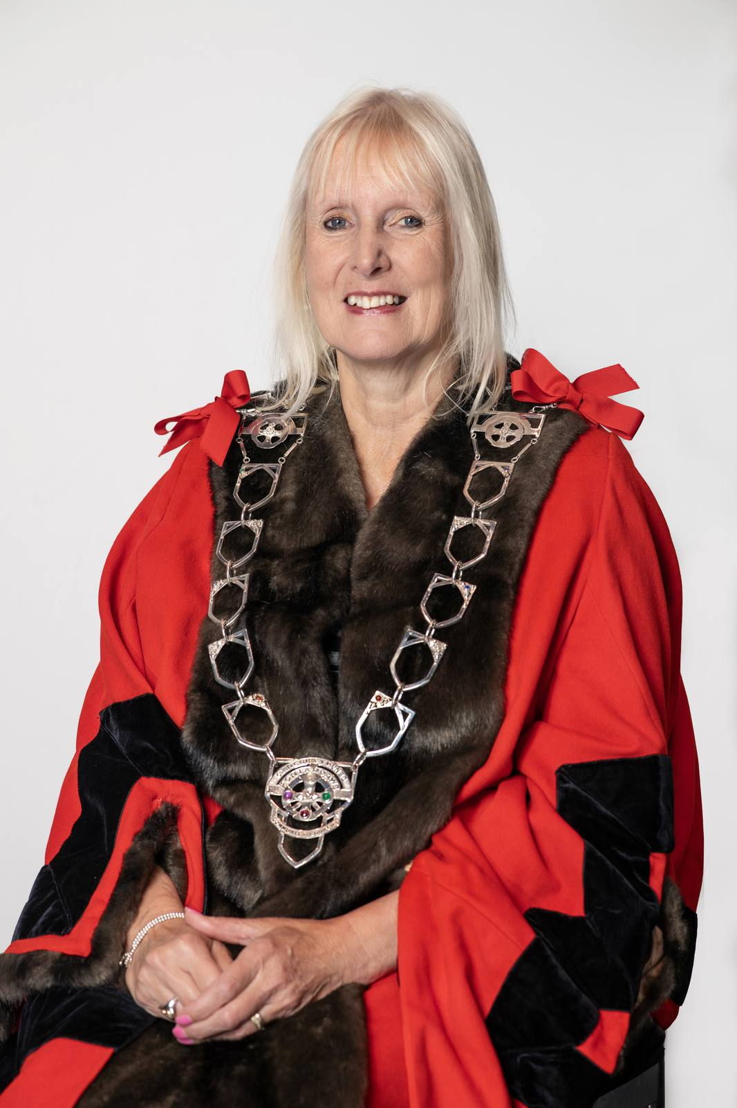

Pontardawe
The town of Pontardawe lies in the Swansea Valley and is named after the bridge crossing the river Tawe name which runs through the town. It appears that some form of a bridge had been in place over the Tawe at this location by 1729, as it features on Emanuel Bowen’s New and Accurate Map of South Wales published in that year. The settlement developed as the crossing point of two drover trails; the one running from Swansea to Brecon, and the other from Neath to Llandeilo. The picturesque canal, now dormant, is evidence of the industrial past of steel, tinplate and coal. Pontardawe is a town with a population of approximately 7,100 according to the 2021 census.

St. Peter’s Church, notable for its French architectural style and affectionately known as “Cadeirlan y Cwm / the Valley’s Cathedral”, was completed in 1862 and its 60m tower and spire continues to stand tall above a town known in the nineteenth-century for its religious Nonconformity and political radicalism.

The Arts Centre at the heart of the town is a blend of contemporary and traditional styles and is steeped in history. Extensive development to include a 70-seat cinema was completed in October 2025. This is now in addition to the main theatre and studio rooms. The Town Council office is also situated in this majestic building.

The resilience of the town and its people were celebrated in the Welsh language poems of D. Gwenallt Jones (1899-1968) and Dafydd Rowlands (1931-2001), and it continues to be a thriving centre of Welsh folk culture, as manifest in the success of Mary Hopkin in the 1970s and the continuation of its annual Pontardawe Festival in August. Pontardawe is twinned with Locminé in Brittany and a Friendship agreement is also in place with Catasauqua, Pennsylvania.

The town has four primary schools within the Town Council’s ward namely, Ysgol Gynradd Gymraeg Pontardawe, Ysgol Gynradd Gymraeg Trebannws, Llangiwg Primary School, and Rhyd-y-fro Primary School. At present, Godre’r Graig Primary School is also located in Pontardawe in temporary buildings on a site adjacent to the town’s secondary school, Cwm Tawe Community School. Pupils choosing to receive their secondary education in Welsh travel a short distance to Ysgol Gymraeg Ystalyfera.

Sports and leisure activities are a large part of life in Pontardawe with clubs ranging from football to bowls, and martial arts to cricket all accessible in the town. Trebanos has an impressive sporting legacy with notable people from the village including rugby union players Bleddyn Bowen, who captained Wales to the 1988 Triple Crown, fly-half Arwel Thomas who was capped 23 times, Robert Jones, who was capped 54 times and helped win the 1988 Triple Crown, together with openside flanker Justin Tipuric who was capped an amazing 93 times for Wales.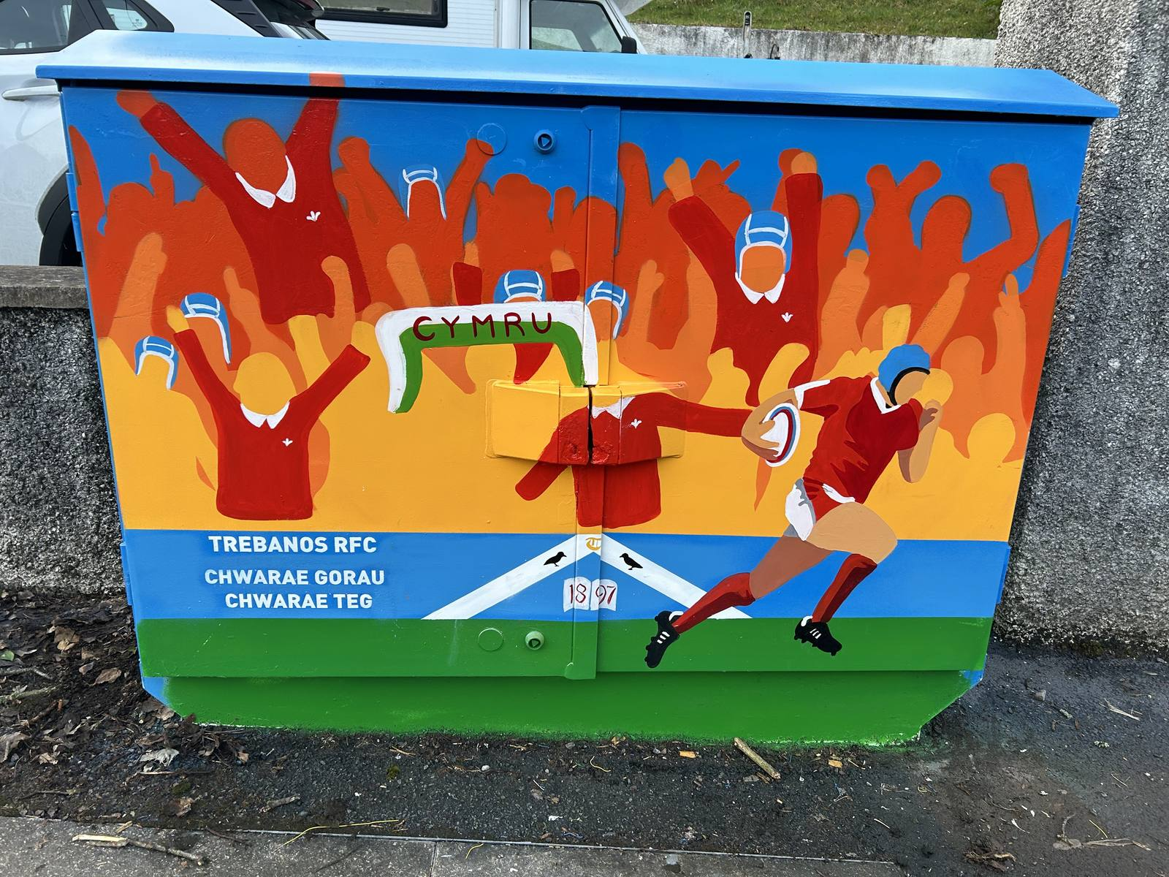

Pontardawe Town Council
Pontardawe Town Council comprises of four separate communities – Pontardawe, Trebanos, Rhyd-y-Fro and Ynysmeudwy, all with their distinct character. The Town Council was originally part of the large Llanguicke Community Council which was separated in 1985/6. The Town Council is comprised of 16 elected members and forms part of the county borough of Neath Port Talbot. Pontardawe Town Council is a separate body to Neath Port Talbot County Borough Council, and therefore, manages different functions and responsibilities.

Pontardawe Town Council’s Annual Report, produced in accordance with requirements of the Local Government and Elections (Wales) Act 2021, aims to inform the community of how the Council delivers against its responsibilities and budgets, who are the elected members of the Council, and provides details of projects that the Council is working to deliver for the town’s benefit.

Pontardawe Town Council Meetings, Decisions and Responsibilities
Pontardawe Town Council, as a body, is responsible for making decisions and managing public money. The Council is open and transparent in decision-making and spending. All decisions are published on the Town Council website within 7 days of a Council meeting being held.

Town Council Ordinary General meetings are held monthly at 6.45pm (usually on the second Monday of each month – except August and Bank Holidays), other committee meetings such as Planning, Policy and Resources, Development, and Eco and Wellbeing are held on the following Monday evenings. Meetings are open to the public, and there is an opportunity for the public to contribute to matters on the agenda, at the beginning of each ordinary meeting.

Details of Committee meetings for the following month are found in each month’s Ordinary General Meeting minutes which can be found on our website http://www.pontardawetowncouncil.gov.wales/

Pontardawe Town Council serve the residents of Pontardawe, Rhyd-y-Fro, Ynysmeudwy and Trebanos and is responsible for a number of assets and facilities. This includes Trebanos, ARCH and Ynysmeudwy Community Halls, Trebanos Park, Ynysmeudwy Park, Parc Chwarae Teg, together with the maintenance of some litter bins, highway seating, bridleways, public footpaths, and part of Cwm Du Glen.

The Town Council also works in partnership with the Unitary Authority, Arts Centre, Chamber of Commerce, local schools, community groups and third sector organisations to obtain grant funding and organise events.

We also provide grants to local groups which can be used for both capital projects and revenue.
Details of finance, policy documents, Council activity and additional information about the Council can be found on our website.

Role within Local Government
Pontardawe Town Council is within one tier of local government, another tier would be Neath Port Talbot County Borough Council as the unitary authority. Both Councils are corporate bodies and therefore decisions are made as a whole. The Town Council has the right to raise money through taxation via a precept and to spend in accordance with the legal powers.

Our current Councillors were elected in 2022, however should an elected Councillor leave within their term, then Councillors can be co-opted by Council if a by-election is not requested by the community.
Council Members come from varied backgrounds and this representation on the Town Council means that they bring a number of skills and areas of expertise to discussion.

The Mayor is the face of the Council, attending events and chairing Town Council meetings. The Town Council also employs staff who are managed by the Clerk, who is the proper officer of the Council, in law. The Clerk provides advice and support and acts to implement Council decisions. The Clerk has a varied role and is answerable only to the Council as a whole.

Neath Port Talbot County Borough Council
Neath Port Talbot County Borough Council is responsible for services including education, health and social services, leisure, refuse and recycling, street cleaning, highways including both roads and pavements – street lighting and libraries, their staff are able to assist with queries relating to these matters and can be contacted by telephone on 01639 686868 or via email, in person or by post. Details of how to contact Neath Port Talbot Council can be found on their web site at https://www.npt.gov.uk/?lang=en-gb

Pontardawe is also represented by elected Members to the Neath Port Talbot Council and who can assist residents with issues relating to Neath Port Talbot Council. The elected Councillors for the Pontardawe ward are Councillor Heath Davies and Councillor Anthony Richards, and for the Trebanos ward it was Councillor Rebeca Phillips who recently resigned her seat following her election to the Senedd. The communities of Ynysmeudwy and Rhyd-y-Fro are covered by the Pontardawe ward Members.

Pontardawe Town Councillors
Representing three wards as follows

Ward | Councillor | Contact Details
Pontardawe | Gary Davies  Labour - Elected | 07580 147304
Pontardawe | Dai Brain  Plaid Cymru - Elected | Cllr.d.brain@gmail.com
Pontardawe | Jill Lord  Labour - Elected | Cllr.J.Lord@gmail.com
Pontardawe | Matt Vincent  Plaid Cymru - Elected | Advertising@southwalesmedia.com
Pontardawe | Meirion Davies  Independent - Elected | info@vesopa.com
Pontardawe | Linet Purcell  Plaid Cymru - Elected | linetpurcell@gmail.com
Pontardawe | Anthony Richards  Plaid Cymru - Elected | cllr.a.j.richards@npt.gov.uk
Pontardawe | Bleddyn Howells  Independent - Elected | Cllr.B.Howells@gmail.com
Pontardawe | Jamie Nemeth  Plaid Cymru - Elected | cllr.j.nemeth@gmail.com
Pontardawe | Heath Davies  Plaid Cymru - Elected | Cllr.h.davies1@npt.gov.uk
Rhyd-y-Fro | Steve Todd  Labour - Elected | Cllr.s.todd@gmail.com
Rhyd-y-Fro | Paul Temblett  Independent - Elected | P.temblett@talk21.com

Trebanos | Gwenno Ffrancon  Plaid Cymru - Elected | Cllr.g.ffrancon@gmail.com
Trebanos | Rebeca Phillips | Stepped down as Councillor following the Senedd Election on the 7th May 2026.  The vacant seat in Trebanos will be filled via a By-election or Co-option
Trebanos | Jamie Watkins  Plaid-Cymru - Elected | jamiehwat@gmail.com
Trebanos | Tudur Jones  Plaid-Cymru -  Co-opted | tudur.ptc@gmail.com
Youth Councillor | Vacancy | town.clerk@pontardawetowncouncil.gov.wales
Youth Councillor | Esther Harper | town.clerk@pontardawetowncouncil.gov.wales

Youth Councillors
Our Youth Councillors provide Council with a young person’s viewpoint with two co-opted each year, initially for a term of one year. Each Youth Councillor is aged between 15 and 26 years old and are an important voice in ensuring diversity within the decision-making process. They also represent Pontardawe Town Council at One Voice Wales committee meetings.

Staff
Pontardawe Town Council employs 5 staff members in 5 part-time positions – there are three part-time Caretakers, one part-time Parks Officer and a part-time Crossing Patrol Officer. The council is also served by a full-time Clerk.

Town Council Finance
Pontardawe Town Council has legal powers to raise money through taxation (the precept) and the Council has a range of powers to enable the spending of public money. The Finance Committee of the Council meets annually to agree the precept for the following financial year. Decisions of the Finance Committee are approved at a full Town Council meeting.
In setting the budget, the Council considers ongoing pressures and projects, as well as looking at other potential sources of funding. In 2025-26 the Precept was agreed at £245585.00

The chart shows the approximate allocation for 2025/26:
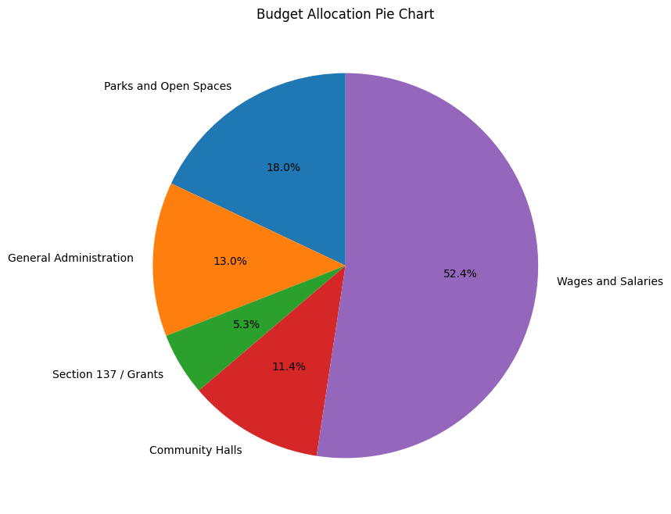
To give context to the figures shown, the areas are broken down to include the following (lists are not exhaustive):

Parks and Community Spaces
Footpaths and Bridleway maintenance
Cwm Du Nature Reserve
Highway seating and litterbins
Hanging baskets and Town Floral decorations
Christmas Lights
Defibrillators

Governance
General Administration
Management of Town Council functions and finance
Support and advice at Town Council meetings
Implementation of Council decisions and organisation of Council procedures
HR Functions
Insurance
Health and Safety
Organisation of Civic Functions and other events
Research and implementation of grant funding
Liaison with Partners and other groups
Media and Social Media
Grants for local groups and Partnership events

Community Halls
Liaison with Community Hall Management Committees
Insurance/ Risk Assessments/ maintenance/ advice

Wages
Staff wages together with tax and pension contributions

Supporting Wellbeing in Pontardawe
Pontardawe Town Council places community wellbeing at the heart of all the decisions made and works to support both the Welsh Government Well-being of Future Generations Act and the Neath Port Talbot Public Service Board well-being objectives.

The Well-being of Future Generations (Wales) Act 2015 requires public bodies in Wales to think about the long-term impact of their decisions, to work better with people, communities and each other, and to prevent persistent problems such as poverty, health inequalities and climate change.

The Neath Port Talbot Public Services Board is made up of four statutory member organisations: Swansea Bay University Health Board, Neath Port Talbot County Borough Council, Natural Resources Wales and Mid and West Wales Fire and Rescue Service. The Board also invites a number of other partners to participate in its activity as ‘invited participants’. The Neath Port Talbot Public Service Board Objectives for 2023-28 are:

Well-being Objective 1: All children have the best start in life
Well-being Objective 2: All our communities will be thriving and sustainable
Well-being Objective 3: Our local environment, culture and heritage can be enjoyed by future generations
Well-being Objective 4: There are more green, secure and well-paid jobs and skills across the area

The table below outlines how Pontardawe Town Council achieves against these four objectives.

Pontardawe Town Council Project or Activity | Well-being Objective 1 –  Children and young people | Well-being Objective 2 – Thriving Communities | Well-being Objective 3 –  Environment, Culture & Heritage | Well-being Objective 4 –  Employment & Skills
Improving the Town Centre experience for visitors and local people (e.g. floral displays, Christmas decorations, flags at key points of the season.) | ✔️ | ✔️ | ✔️ | ✔️
Financially supporting family focussed events and festivals in the town such as the Pontardawe Winterfest, the King George V Park fete and St Peter’s Flower Festival. | ✔️ | ✔️ | ✔️ | ✔️
Providing Community Halls free of charge to Youth Clubs in Ynysmeudwy and Trebanos | ✔️ | ✔️ | ✔️ | ✔️
Councillors act as Minor Authority Governors at local Primary and Secondary Schools | ✔️ | ✔️
Children’s activity groups well represented at all three Community Halls | ✔️ | ✔️
Well maintained and adventurous play equipment at all three parks | ✔️ | ✔️ | ✔️
Grant funding support for local sports, wellbeing, heritage, cultural and environmental groups | ✔️ | ✔️ | ✔️ | ✔️
Financing the Crossing Support Officer for Swansea Road adjacent to Cwmtawe School | ✔️ | ✔️ |  | ✔️
Annual co-option of Youth Councillors to ensure diversity and the voice of the town’s youth is heard | ✔️ | ✔️ |  | ✔️
Partnership working on events with the Arts Centre, Chamber of Commerce, Pontardawe Heritage Centre, Menter Iaith Castell-nedd Port Talbot and others | ✔️ | ✔️ | ✔️ | ✔️
Installation of CCTV in the town centre in partnership with Neath Port Talbot Council |  | ✔️ |  | ✔️
Participation in the creation of the Neath Port Talbot Place Plan for Pontardawe, in conjunction with ‘The Urbanists’ | ✔️ | ✔️ | ✔️ | ✔️
Acting as guardian of several defibrillators within the Town Council area |  | ✔️
Support for the Pontardawe Twinning Events with Locminé and the signing of the Catasauqua Friendship agreement | ✔️ | ✔️ | ✔️ | ✔️
Support for the Friends of King George V Park project to refurbish the derelict tennis courts. | ✔️ | ✔️ | ✔️ | ✔️
Management of part of the Cwm Du Nature Reserve |  | ✔️ | ✔️
Creation of a Street Art Heritage Trail on Openreach boxes and benches within the town and support of the Cwm Tawe Eisteddfod |  | ✔️ | ✔️
Liaison and grant funding for a range of environmentally-focussed volunteer groups e.g. My Green Valley, Pontardawe Conservation Volunteers and Pontardawe Repair Cafe |  | ✔️ | ✔️ | ✔️
Support of small businesses and community enterprises such as the Pontardawe Hwb and wellbeing space |  | ✔️ |  | ✔️
Mayor and Councillors liaison with local business owners to identify and address issues. |  | ✔️ |  | ✔️
Encouraging business within the Town Centre with one-hour free parking |  | ✔️ |  | ✔️
Encouraging start-ups by supporting a thriving Town Centre which is a pleasure to visit |  | ✔️ |  | ✔️

Addressing the goals of The Well-being of Future Generations Act (2015)

There are 7 connected well-being goals for Wales. They are:

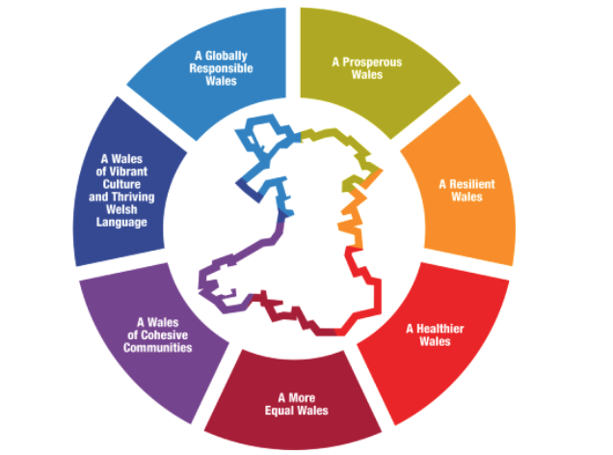

Pontardawe Town Councils works to address these goals through its business-as-usual activities but also through instigating and leading a range of different activities and projects, often in partnership with other bodies and societies.

There continues to be a cost-of-living crisis for many and while the Town Council does not have direct control over social services, education or housing, it does work closely with the County Borough, to ensure that issues at a local level are efficiently reported, via our County Borough Members, who are all also Town Councillors.

Over the past year, the Town Council maintained parks provided free entertainment for young people and our Community Halls are heavily subsidised to enable them to be run as community assets rather than as a source of revenue. With costs for group activities and one-off events, such as children’s parties being very reasonably priced.

By providing outdoor space at Parc Chwarae Teg in Rhyd-y-Fro, in Ynysmeudwy and at Trebanos Park, the Council is committed to supporting the health of residents in the Pontardawe area. The Council ensures that the parks are regularly maintained and safe for use by the public. Parc Chwarae Teg is a children’s play area and MUGA. Trebanos Park encompasses both the Rugby ground and changing rooms (these are leased to Trebanos Rugby Club) and a children’s play area. Ynysmeudwy Park holds a children’s play area, MUGA and supports an environmental project to plant trees, create bug and bird boxes and to maintain a meadow area. We are also working in partnership with Neath Port Talbot Council to refurbish the derelict tennis courts at King George V Park.

The Town Council works in partnership with the Neath Port Talbot Town Centre Officer, the Pontardawe Arts Centre, Chamber of Commerce, Pontardawe Heritage Centre, Royal British Legion and Menter Iaith Castell-nedd Port Talbot, alongside others, to promote the Town and to organise festivals and events to encourage footfall to the area. The Town Council also financially support through the grants process, in total or in part, a number of events and activities within Pontardawe. These include fireworks, the Tree of Light, carnivals, Christmas events, fetes, food festivals, and town centre flags. Working together with our County Borough Members, the Royal British Legion and Pontardawe Veterans, the Town Council has led on arrangements to deliver future Remembrance events.

The Town Council is committed to the development of young people in the area and have provided the second hall area at Ynysmeudwy as a permanent home for the Youth club, free of charge. It has also supported the creation of the Welsh Language Youth Club in Trebanos Hall. Town Council grants (both capital and revenue) are available for local groups and organisations to assist with their costs.

Pontardawe Town Council is committed to ensuring that the town remains a pleasant, clean and safe environment. To further aid this aim, alongside Neath Port Talbot Council and the local Police Force we finance a CCTV system which provides a 24/7 ‘live’ feed from Pontardawe Town Centre. Councillors consider monthly reviews of Police statistics at the Ordinary General meeting and receive monthly reports from County Borough Members on both high level and local actions. The Town Council is also a supporter of Dementia Friendly Communities and is guardian for several Defibrillators, all of which are connected to the Circuit. Pontardawe Town Council also financially supports the Crossing Patrol Officer at Swansea Road in conjunction with Cwmtawe School and Neath Port Talbot Council to ensure our young people reach their school safely.

Pontardawe Town Council is not responsible for any highways or street cleaning; however, we have developed excellent working relationships with the responsible authority. Street Cleaning, litter collection, refuse and recycling are the responsibility of Neath Port Talbot Council but colleagues on the Town Council can support these services in reporting and addressing areas of concern. The Town Council has also provided some litter bins within Pontardawe together with additional highway seating. Grants have also been provided to My Green Valley to assist in volunteer litter picks.

The Town Council acts as consultee on Planning matters and observations are then made to the Local Planning Authority on any issues which are perceived to be a detriment to the town.

Town Councillors are also liaising with Neath Port Talbot Council and The Urbanists to support the Town Team Project which aims to create a Community and Place Plan to future-proof and support both the retail park, Town Centre and the Industrial Estate through supplementary planning. The Town Council also monitors the unused County Borough buildings such as the Cross and Gelligron House and actively engages in discussions on means of bringing these assets back into community use.
The Town Council is also actively working in conjunction with Neath Port Talbot Council to identify funding in order to construct a replacement swimming pool

Town Councillors are also present on various liaison committees to support both business and the environment in the local area (i.e. Pwllfawatkin liaison and Gwrhyd Quarry Liaison)
The Town Council has an Environmental Statement which was created in under the Environment (Wales) Act 2016 to maintain and enhance biodiversity and was updated in 2025.

The Town Council supports the Welsh language in a range of ways. We have recently supported the Cwm Tawe Eisteddfod and continue to support the Welsh Language Youth Club at Trebanos Hall, in partnership with NPT Youth Services. We promote bilingualism with a bilingual website and we have partnered with Menter Iaith Castell-nedd Port Talbot on several projects and events that promote the use of the Welsh language. Tŷ'r Gwrhyd, the Pontardawe Welsh Language Centre, is located on Holly Street in Pontardawe and supports the Council's activities, including the Pontardawe Repair Cafe. Our Councillors are Minor Authority Governors at YGG Trebannws and YGG Pontardawe. Grants have been provided to both the Urdd Gobaith Cymru and the National Eisteddfod. Pontardawe Town Council is also included within the institute of Welsh Affairs ‘Understanding Welsh Places’ project.

The Town Council also sources grant income from other bodies in order to improve the community in various ways. This year we specifically focussed on play and the environment and succeeded in capturing a second grant from the Nature Partnership Biodiversity fund and a small grant from a Neath Port Talbot Council to improve safety at Ynysmeudwy park

Our heritage street art project enabled cross-generational collaboration to share views and information that helped us highlight landmarks, individuals, and other elements of our heritage, that reflect and make Pontardawe’ s culture visible to residents and visitors alike. The Project provided visually stunning artwork on Openreach boxes and benches that have stimulated discussion and enhanced the appearance of the town.

The second Biodiversity Project allowed further area of invasive rhododendrons to be treated by specialist contractors at Gellionen Common. Over time this will reduce the canopy and allow native species to recolonise the area. Volunteer days will also be arranged to address smaller infestations and to encourage community engagement in the area.

As well as sourcing grants, the Town Council also provides grants for local groups, working in partnership to ensure funding for a variety of local groups. £13,000 was provided in grant income to these groups during 2025-26 to help all ages and to support both revenue and capital projects.

Grants Awarded by Pontardawe Town Council 2025-26:

Pontardawe Cricket Club | £1000
Friends of King George V Park | £500
Alltwen Heels WI | £300
Pontardawe Heritage Centre | £1500
Heart of the Valley Show | £999
Pontardawe Chamber of Trade | £834
Pontardawe Arena | £1000
Pontardawe Pride | £500
Swansea Valley Sabres | £900
Brighter Futures | £500
Flower Festival | £150
Pontardawe Repair Cafe | £150
Pontardawe Conservation volunteers | £865.50
Swansea Valley Cardiac Support | £600
Community Clothes swap | £274.44
Pontardawe Sports and recreation | £950
Glantawe Lions | £150
Empower Inspire | £400
Pontardawe Town FC | £677.06
Eisteddfod Cwm Tawe | £750
TOTAL | £13,000

At a glance - Council Achievements in 2025/26
- Summer floral display within the Pontardawe Town Centre and a planter at Trebanos and Rhyd-y-Fro
- Pontardawe Winterfest – Christmas tree and lights, a fancy-dress competition and fireworks to celebrate, and a Christmas Festive Town Centre window competition
- Support for Events in the Community such as the King George V Park family fun day, Pontardawe Pride, Glantawe Lions ‘Tree of Light’, Pontardawe food festival, Pontardawe Flower festival, the Green Gathering and the Heart of the Valley show
- Management of Cwm Du Nature Reserve including addressing ash dieback and the reinstatement of the circular path in conjunction with the Pontardawe Conservation volunteers
- Volunteer days to improve our natural surroundings and encourage a sense of community
- A Civic Service at St Peters Church with collections to the Coeliac Society & Cwm Tawe Eisteddfod.
- Continued support of the Pantry foodbank, the Repair Café, Community clothes swap and two youth clubs
- Representing community views on key developments or changes afoot in Pontardawe, from the need to replace the swimming pool, the future of The Cross and the Pontardawe Place Plan in conjunction with Neath Port Talbot Council
- Continuous improvements of our Community Halls and children’s play areas
- Employment of a Swansea Road Crossing Patrol Officer
- Engaging with a variety of Welsh Government consultations
- Liaison with the Royal British Legion to organise the Pontardawe Remembrance Parade
- Support for the Greatest yarn, and Monthly exhibitions at Pontardawe Heritage Centre
- Support for sports groups and the Pontardawe Sports and Recreation ground to encourage healthy outdoor activities
- Support for other local societies, groups and clubs who work to improve the lives of the residents of Pontardawe

A Year in Pictures

