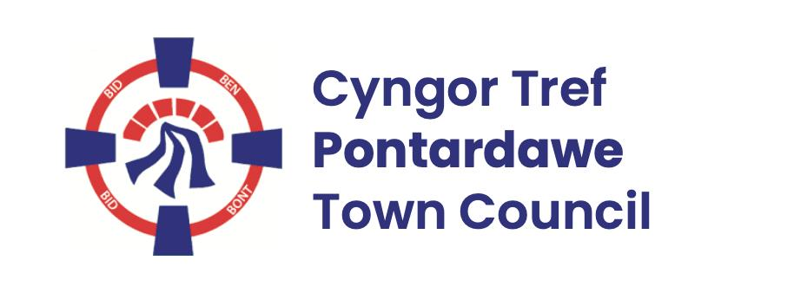
Pontardawe Town Council, Office 2, 2nd floor, Pontardawe Arts Centre, Herbert Street, Pontardawe SA84ED
Email: town.clerk@pontardawetowncouncil.gov.wales
Telephone 07827972226

1st May 2026

Dear Councillor
I wish to inform you that the Annual General Meeting of the above Council will be held on Monday 11th May 2026 at the Gallery, Pontardawe Arts Centre, Herbert Street, Pontardawe SA8 4ED with hybrid facilities by online platform Zoom, commencing at 6.45pm
I trust that you will be able to attend.

Yours faithfully
D Phillips
Town Clerk

AGENDA

- Election of Mayor 2026/27
- Election of Deputy Mayor 2026/27
- Adopt Standing Orders 2026/27
- Adopt Financial Regulation 2026/27
- To agree Mayor’s & Deputy Mayors allowance for 2026/27
- Agree Members Code of Conduct
- To agree Committees terms of reference
- To elect Members to serve on Council’s Committees 2026/27: Policy & Resources (Mayor & Deputy Mayor plus 6 Members), Planning (Mayor & Deputy Mayor plus 6 Members), Finance (Mayor & Deputy Mayor plus 6 Members), Personnel (Mayor & Deputy Mayor plus 6 Members), Development (Mayor & Deputy Mayor plus 6 Members), Eco & Wellbeing Committee (7 Members), Community Plan Steering Committee (7 Members)
- To elect Members to serve on other Committees 2026/27: One Voice Wales (1 Member plus 1 Deputy), Town & Community Council Liaison Committee (Mayor plus one Member as Deputy), Pwllfawatkin Liaison (2 Members plus 2 Deputies), WREN (1 Member), Cwmnantllechi Liaison (1 Member and 1 Deputy), Arena/ Riverside Project (1 Member plus 1 Deputy) Gwrhyd Liaison (1 Member and 1 Deputy), Dementia Friendly champion (1 Member), NPT Nature forum (2 Members)
- Bank Reconciliation Quarterly review (Members who do not hold a banking Mandate)
- Bank Account Mandates – Unity Trust (4 Members), Nationwide and Credit Union (3 Members)
- Annual Accounts
- Assertion 10 Policies – Document retention and disposal, Information data protection, Information security, Information security breach, mobile device, removable media and social media, Publication (Freedom of Information) Policies
- General Policies – Training and Development, Health and Safety, Grants, Local resolution, dignity at work, lone working, arboricultural, Equality and Diversity and publicity policies

