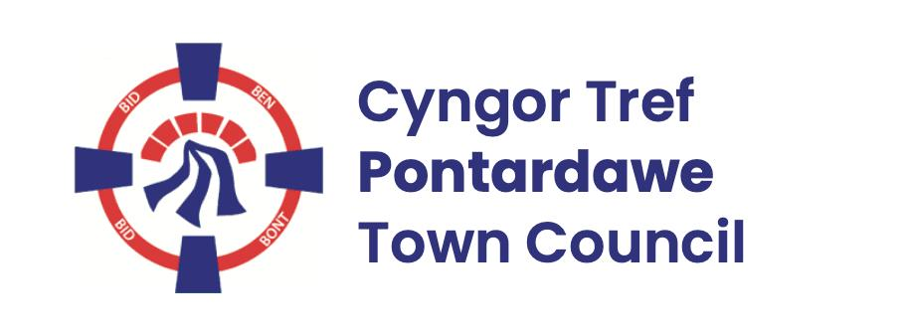
Pontardawe Town Council, Office 2, 2nd floor, Pontardawe Arts Centre, Herbert Street, Pontardawe SA84ED
Email: town.clerk@pontardawetowncouncil.gov.wales
Telephone 07827972226
5th May 2026

Dear Councillor
I wish to inform you that there will be an Ordinary General Meeting on the 11th May 2026. A Hybrid facility will be available. The physical meeting will take place at the Gallery, 2nd Floor, Pontardawe Arts Centre, Herbert Street, Pontardawe SA8 4ED. There will also be access via the virtual platform Zoom and will commence following the Annual General Meeting
I trust that you will be able to attend.

Yours faithfully / Yn gywir
D. Phillips
Town Clerk / Clerc y Dref

Agenda
1. Apologies for absence.
2. Disclosure of personal and pecuniary interest in items of business listed below.
3. Signing of the minutes of previous Ordinary Meeting held on the 13th April 2026.
4. To consider matters raised by members of the public (N.B such matters will be
reported upon by the Town Clerk at the next meeting, where appropriate)
5. Presentation by Claire Phillips – Regional Foster Wales recruitment Officer
6. Matters arising:
13087 – Trebanos Hall Refurbishment
13088 - Police Matters – Clerk to provide details from the ‘Our Bobby’ web site.
13089- Monthly update from Neath Port Talbot County Borough Council Members
13090 – Grant Applications and letters of thanks
13091 – Eco & Wellbeing – project updates
13092 – Significant Closures (Pontardawe Swimming pool, The Cross Community Centre and Gelligron House)
13093 – Place Plans /The Urbanists
13094 – Blue Plaque
13097 – Remembrance
13098 – Christmas 2026
7. Reports
Planning
Internal Auditors final report for 2025/26 (Interim already reviewed)
Annual Return 2025/26
Insurance Renewal
8. Accounts Schedule 436 totalling £21347.54 together with Bank reconciliation
9. Correspondence
- Correspondence re procedure
- HOREB Chapel graveyard
10. Open Consultations relating to the public sector – Links on the Members area of the Website:
None
11. Urgent Road Safety Matters plus previous responses
12. Date of Next Ordinary Meeting- To confirm that the next Ordinary meeting will be held on the 8th June 2026 with hybrid facilities. The physical meeting will be held at the Gallery, 2nd Floor, Pontardawe Arts Centre, Herbert Street, Pontardawe SA8 4ED with support from the virtual platform Zoom

